San Joaquin County: Data Notebook 2014
for California
Mental Health Boards and Commissions
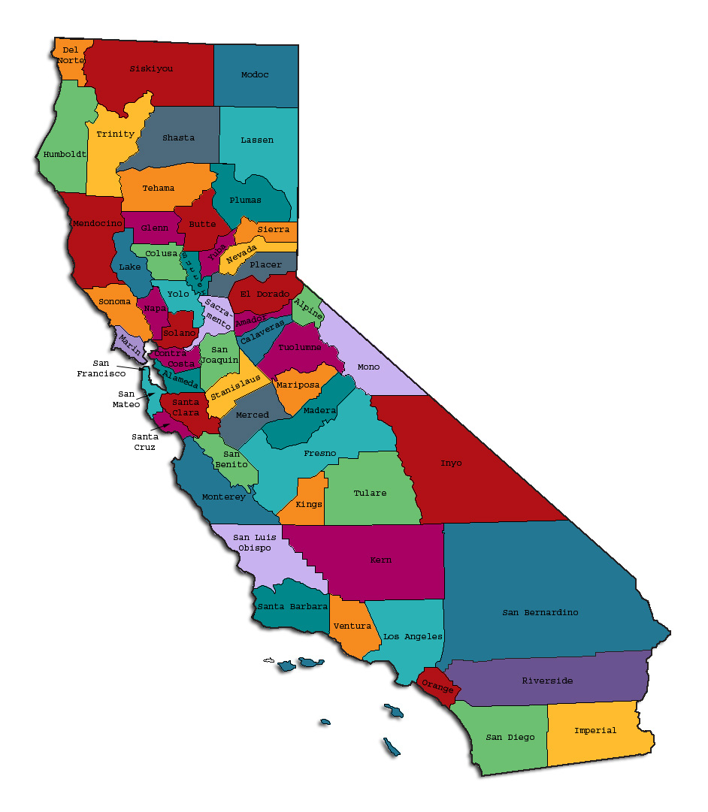
Prepared by California Mental Health Planning Council, in collaboration with:
California Association of Mental Health Boards/Commissions, and APS Healthcare/EQRO
This Page Intentionally Left Blank.
Date: April 20, 2014
To: Chairpersons and/or Directors
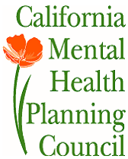
Local Mental Health Boards and Commissions
From: California Mental Health Planning Council
Subject: Instructions for Data Notebook 2014

We ask that this report be prepared by the MH Board or Commission members. You are the most important resources for identifying program strengths and needs in your community.
On the first page, please fill in the requested information for your county websites:
- Department of Behavioral Health/ Mental Health
- Public reports about your county’s MH services.
Please send the filled-in first page to the Planning Council along with your final report which contains your answers to the questions in the Data Notebook. Please submit your report to :
DataNotebook@cmhpc.ca.gov.
Or, you may mail a printed copy of your report to:
- Data Notebook Project
- California Mental Health Planning Council
- 1501 Capitol Avenue, MS 2706
- P.O. Box 997413 Sacramento, CA 95899-7413
Please examine the enclosed information, which will help you discuss the questions in the Data Notebook. We provide examples of recent mental health data for your county. In some figures, the term “MHP” is used to refer to your county’s Mental Health Plan.
Some data comes from APS Healthcare/EQRO, which gave permission to use their figures and tables, prepared for review of each county’s Medi-Cal Specialty Mental Health services. Data in this packet came from the following review cycle:
__X__ Fiscal Year 2013 -- 2014: http://caeqro.com/webx/.ee85675/
For some questions, you will need to consult your local county Quality Improvement Coordinator, and/or Mental Health Director. If you are not able to address all of the questions, just answer the ones you can.
Thank you for your participation in the Data Notebook Project.
This Page Intentionally Left Blank

San Joaquin County: Data Notebook 2014 for California
Mental Health Boards and Commissions

County Name: San Joaquin Population (2013): 703,919
Website for County Department of Mental Health (MH) or Behavioral Health: http://sjgov.org/MHS/
Website for Local County MH Data and Reports: http://sjgov.org/MHS/
Website for local MH Board/Commission Meeting Announcements and Reports:
http://www.sjgov.org/mhs/General_Info/mental_health_board.htm
Specialty MH Data from review Year 2013-2014: http://caeqro.com/webx/.ee85675
Total number of persons receiving Medi-Cal in your county (2012): 229,626
Average number Medi-Cal eligible persons per month: 189,388
Percent of Medi-Cal eligible persons who were:
Children, ages 0-17: 48.1 %
Adults, ages 18-59: 40.8 %
Adults, Ages 60 and Over: 11.1 %
Total persons with SMI or SED who received Specialty MH services (2012): 9,857
Percent of Specialty MH service recipients who were:
Children 0-17: 32.4 %
Adults 18-59: 57.8 %
Adults 60 and Over: 9.8 %
This Page Intentionally Left Blank
INTRODUCTION: Purpose, Goals, and Data Resources
This Data Notebook has been developed for the use by the local mental health (MH) boards and commissions by a yearlong workgroup comprised of members from:
- California Mental Health Planning Council (CMHPC)
- California Association of Local Mental Health Boards and Commissions (CALMHB/C)
- APS Healthcare/ EQRO (External Quality Review Organization)
Our plan is for the Data Notebook to meet these goals:
- assist local boards to meet their mandates to review the local county mental health systems, identify unmet needs, and recommend improvements.
- provide a professional format for submitting reports to their local Board of Supervisors, and/or their county Director of Mental Health Services.
- function as an educational tool for local boards, whose members have varying levels of skills, frequent turnover, and need ‘refresher’ training about using data.
- help the CMHPC fulfill its mandates to review and report on the public mental health system in California, which also helps provide evidence for advocacy.
Data reporting drives policy, and policy drives funding for programs. But the data must be both recent and available to the public, or else it is not useful. So, the CMHPC will provide examples of local data from current public reports. We focus on two broad areas: (1) evaluation of program performance, and (2) indicators of client outcomes.
We recognize that each county has a unique population, resources, strengths, and needs. Thus, there is no single perfect data source to answer all the important questions one might ask about mental health services. However, the following data resources will help board members answer questions in this Data Notebook:
- experience and opinions of the local mental health board members
- recent reports about county MH programs from APS Healthcare/EQRO
- data you request from your county QI Coordinator and/or Mental Health Director (because CMHPC does not have that data, and it’s not in other public reports)
- client outcomes data provided by California Institute of Mental Health (CiMH) in their analysis of the most recent Consumer Perception Survey.
Some of our data comes from APS Healthcare/EQRO, which kindly gave permission to use their figures and tables, prepared for review of each county’s Medi-Cal Specialty Mental Health services. Those reviews are at: www.CAEQRO.com. You may find the full-length EQRO reports helpful because they summarize key programs and quality improvement efforts for each county. They also describe strengths, opportunities for improvement, and changes in mental health programs since the last year.
Understanding changes in local programs can help consumers because of the massive re-organization of mental health services statewide. Some changes have been confusing to clients. The old state Department of Mental Health was eliminated in 2012 and many functions were moved to the Department of Health Care Services. Other changes due to federal health care reform and the Affordable Care Act affect how mental health services are provided, funded, and linked to primary health care or substance use treatment. Also, local counties have adjusted to major challenges.
Remember, this report is about your community, and what you and your stakeholders choose to discuss. Examining the data can indeed “Tell a Human Story.” But quantitative data (numbers) provides only part of the picture, for example:
- measures of whether the quality of program services improve over time
- whether more people from different groups are receiving services
- how many clients got physical healthcare or needed substance use treatment.
The other part of the story gives human context to the numbers. Such qualitative data (narrative, descriptions, or stories) tells more of the story, because we can:
- describe special programs targeted for outreach to specific groups
- examine how the programs are actually implementing their goals
- list concrete steps that are taken to improve services, and
- tell what is being done to increase client engagement with continued treatment.
We hope this project contributes to ongoing quality improvement (QI) in mental health services. We seek constant improvement in our approach to quality because:
- needs change over time,
- all human endeavors are by nature imperfect,
- creativity gives rise to new ideas, and
- we can share examples of successful programs to help other communities.
One question is whether local boards are permitted to provide additional information, besides that requested in this Notebook. We always welcome supplemental reports about successful projects, or which the county administration uses to inform the public. Any additional reports may be attached in an “Appendix,” with the website address (if available). However, we emphasize such extra reports are not required.
Thank you for participating in this project. We hope this Data Notebook serves as a springboard for your discussion about all areas of the mental health system, not just those topics highlighted by our questions.
TREATING THE WHOLE PERSON:
Integrating Behavioral and Physical Health Care
Studies have shown that individuals with serious mental illness die, on average, 25 years earlier than the general population. This information makes improving the physical health of clients of great importance and should be a goal of county mental health departments along with providing effective and appropriate mental health services. Coordination of care for mental health, substance abuse and physical health is one way of accomplishing the goal.
The California Mental Health Planning Council does not have any data to provide to show how your county’s programs connect clients of mental health services with necessary physical health care. We ask that the local mental health board request information from your county mental health department for any data on numbers (or percent) of total mental health clients who are referred to, or connected with, physical health providers to assess, treat and monitor physical health issues.
If your county has data on numbers or percentages of clients who are also receiving physical health care, please include it in your Data Notebook you submit to the Council.
- Check here if your county does not have such data or information.

1) Please describe any efforts in your county to improve the physical health of clients.
Upon passage of the ACA, BHS deployed two part-time Outreach Specialists to help uninsured clients sign up for the Medi-Cal. Outreach staff help clients fill out applications. Staffing has since been increased four part-time outreach workers and there are plans to increase that number.

2) How does your county address wellness programs to engage and motivate clients to take charge of improving their physical health?
BHS participates in the Network for a Healthy California’s Champions for Change initiative by training BHS staff in healthy eating and lifestyle options and particularly training board and care operators to prepare healthier meals.
BHS supports a Consumer Health Empowerment Initiative and participates in SAMHSA’s 10 by 10 Campaign, a national project to improve life expectancy by 10 years in 10 years for people with mental illness. Peer outreach workers educate consumers on the eight dimensions of wellness, which include physical wellness.

BHS co-sponsors a health fair each year for our clients in collaboration with the Consumer Advisory Council. This year, the health fair is on November 14. BHS sponsors an 8-week diabetes workshop several times per year, and are launching a Healthy Living Program, which is a 6-8 week workshop to help people living with chronic illness

BHS maintains a smoke-free campus and encourages clients to participate in the Medi-Cal Incentives to Quit Smoking (MIQS).
During WRAP trainings, participants are encouraged to participate in an Instant Recess, modeled after workplace wellness programs that encourage mobility during long meetings.

NEW CLIENTS: One Measure of Access
One way to evaluate the quality of mental health services outreach is to measure how many clients receive services who have never been part of the service system before (“brand new” clients). Another measure is how many clients return for services after a period of time with no services (“new” clients).
The California Mental Health Planning Council is exploring how each county mental health department defines “new” clients, and how a client is labelled when they return for additional services. This information is important in determining whether your county has a “revolving door,” that is, clients who are in and out of mental health services repeatedly. This data is one indicator of the success of your county’s programs in closing cases appropriately and providing adequate discharge planning to clients.
This data is not currently reported by the counties to the state. The Council does not have data to provide to you. This information should be requested from your county mental health department.
____ Check here if your county does not have this information.
3. How does your county define 'new' client for those individuals who have previously received services, but who have not received services for a while? (e.g., 6 months, 12 months, 2 years?)
BHS defines “new” as never having received services before.
4. Please provide any data your county has on the number of 'new' clients last year. And if you have it, how many of those new clients were brand new clients? You may need to ask your county mental health department for this data.
# new children/youth (0-17 yrs) 1,982
of these, how many (or %) are ‘brand new’ clients 100%

# new adults (18-59 yrs) 2,470
of these, how many (or %) are ‘brand new’ clients 100%

# new older adults (60+ yrs) 146
of these, how many (or %) are ‘brand new’ clients 100%
REDUCING RE-HOSPITALIZATION: Access to Follow-up Care
Sometimes, an individual experiences acute symptoms of mental illness or substance abuse which can result in a brief stay in an acute care hospital. Receiving follow-up services after discharge from a short-term (3-14 day) hospitalization can be critical to preventing a return to the hospital.
The chart below shows the percentage of people discharged in your county who received at least one service within 7 days of discharge. Also shown is the percentage of those same people who were readmitted to the hospital. The chart also shows the same information for receiving services and being readmitted to the hospital within 30 days. Red indicates the numbers for services or events within 30 days, and the blue indicates services or events within 7 days of patient discharge. (CY = Calendar Year, e.g., 2011 or 2012, as indicated below).

San Joaquin County:
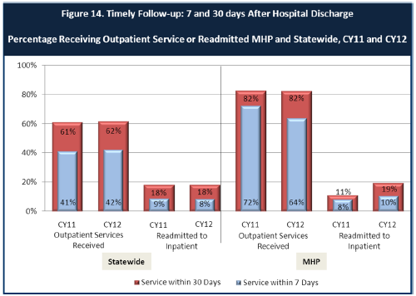

6. Looking at the chart, is your county doing better or worse than the state? Discuss why (e.g., your county has programming available that specifically ensures a warm handoff for follow-up services).
San Joaquin County is doing as well as or better than the state in hospital readmissions. This is largely due to a post-hospitalization clinic that provides timely follow up for PHF discharges. In addition, when clients admitted to out-of-county hospitals are transported upon hospital discharge, they are seen at the post-hospitalization clinic to evaluate needs and ensure an adequate, appropriate discharge plan.

7. Do you have any suggestions on how your county can improve follow-up and reduce re-hospitalizations?
San Joaquin County is already far surpassing statewide results in outpatient services; however, BHS continues to investigate opportunities to improve engagement and access to outpatient services. Through SB82, BHS will be adding eight crisis stabilization beds (4 adult voluntary & 4 youth) that will provide more alternatives to hospitalization.

8. What are the three most significant barriers to service access?
- Staff shortages, especially psychiatrists, child therapists, after-hour crisis response, and other mental health professionals. This is due, in part, to the higher salaries offered by the new mental health correctional facility located in San Joaquin County.

- Stigma is a barrier to accessing early and timely mental health services.

- There is a need for universal staff training in evidence-based practices.

ACCESS BY UNSERVED AND UNDER-SERVED COMMUNITIES
One goal of the Mental Health Services Act (MHSA) is to reach unserved and underserved communities, especially communities of color. The MHSA promotes outreach into these communities to engage these communities in services. If individuals and families in these communities are not accessing services, then we may need to explore new ways of reaching them. Or, we may need to change our programs to meet their mental health needs in ways that better complement their culture.
From data the counties report to the state, we can see how many individuals living in your county are eligible for Medi-Cal, and of those individuals, how many received mental health services. Are you serving the Medi-Cal clients who need your services?
San Joaquin County Data:
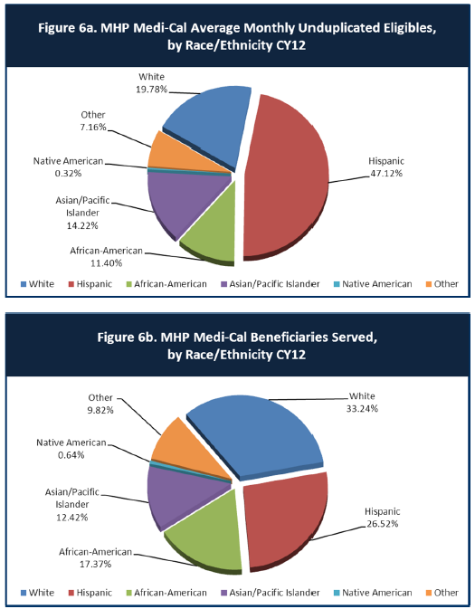

9. Is there a big difference between the race/ethnicity breakdown on the two charts? Do you feel that the group(s) that need services in your county are receiving services?
The above figures suggest that Whites, African Americans, and Native Americans are sufficiently served, as a group. Latinos and, to a small degree, Asian/Pacific Islanders are underserved and may need additional services and supports.
10. What outreach efforts are being made to reach minority groups in your community?
Several of San Joaquin County’s PEI projects are run by Community Based Organizations (CBOs), whose diverse staff are trained in Mental Health First Aid, particularly in how to recognize signs and symptoms, identify individuals experiencing crises, and navigate services. NAMI trainings in English and Spanish help to overcome stigma among providers and self-stigma among consumers, which as a result helps BHS reach minority groups who would otherwise resist behavioral health services.
Starting in 2015, PEI projects that reach out to minority groups will include Trauma Services for Children, which trains public school staff to recognize trauma responses among the diverse student population and refer families to trauma screenings and short-term trauma interventions, including Cognitive Behavioral Therapy and Seeking Safety. School staff will be trained in linking students with Severe Emotional Disturbance to BHS for more comprehensive assessments. Suicide prevention programs are also run in public schools, which reach all of the diverse populations of San Joaquin County
With PEI funds, BHS has and will continue to offer skill-building classes for parents and guardians in community-based locations. To attract participants, bilingual (Spanish/English) staff of Catholic Charities, Child Abuse Prevention Council, Community Partnership for Families, El Concilio, and Parents by Choice reach out to locations throughout the County to attract families.
Until 2013/14, the PEI component of MHSA funded nine ethnically specific Cultural Brokers from eight CBOs. Brokers conducted general outreach and provided educational presentations for mental health staff and for community organizations and community events. Brokers outreached directly to individuals with signs and symptoms of mental illness with the goal of referring them to mental health screenings.
Starting in 14/15, in-lieu of Cultural Brokers, cultural CBOs will receive CSS funding to employ Recovery Coaches. Rather than more general outreach, the Recovery Coaches will target FSP-eligible individuals. Recovery Coaches will be embedded in three FSP sites, and will provide home and community visits. Recovery Coaches will provide culturally appropriate resources and help encourage engagement with FSP providers. For example, a local Latino organization, El Concilio, will provide support to the Latino-oriented La Familia FSP. Three Asian organizations, VIVO, Lao Family and APSARA, will provide support to the Asian-oriented SEARS FSP
BHS sponsors a monthly consortium of cultural CBOs, which involves consumers and family members, and provides education and an opportunity to network with other minority-oriented outreach organizations. BHS also sponsors a Cultural Competency Committee, which includes LGBT and Latino subcommittees. BHS employs an Ethnic Services Manager, who participates in regional and statewide activities related to minority outreach and cultural competency. The Ethnic Services Manager and Limited English Proficiency Coordinator are tasked with promoting cultural competency among all staff.
BHS translates all outreach brochures into the three threshold languages. The department employs paid interpreters who are bilingual in five languages, and uses telemedicine and phone interpretation to ensure non-English speakers receive interpretation services. Providing services via bilingual staff or interpreters helps to ensure that outreach efforts are successful and that individuals who are reached out to can take advantage of services.

11. Do you have suggestions for improving outreach to and/or programs for underserved groups?
Continue to eliminate cultural and linguistic barriers for underserved groups, including Latino, Southeast Asian, American Indian, African Americans, Middle Eastern and LGBT. Continue to hire and maintain staff who reflect the makeup of San Joaquin County’s racial and ethnic communities. Continue to post required literature in threshold languages throughout BHS campus, clinics and at CBOs.
Sponsor public radio and television announcements.

CLIENT ENGAGEMENT IN SERVICES
One MHSA goal is to connect individuals to services they need to be successful. Clients who stop services too soon may not achieve much improvement, nor is it likely to last. So it is important to measure not only who comes in for treatment, but also how long they stay in services. Here we are considering individuals with high service needs, not someone who just needs a ‘tune-up.’ Although not every individual needs the same amount of services, research shows that when someone with severe mental illness continues to receive services over time, their chances of recovery increase.
Engagement in services, also called ‘retention rate’, is important to review. If individuals come in, receive only one or two services and never come back, it may mean the services were not appropriate, or that the individual did not feel welcome, or some other reason that should be explored. Again, we recognize that some individuals only need minimal services, but here we are looking at those with severe mental illness. Ultimately, the goal is to ensure they are getting needed services and are on the road to recovery. But we would not know that unless we look at how many services individuals received over time.
The chart below shows the number of Medi-Cal beneficiaries in your county who received 1, or 2, or 3, or 4, or 5, or more than15 mental health services during the year. For individuals experiencing severe mental illness, the more engaged they are in services, the greater the chance for lasting improvements in mental health.

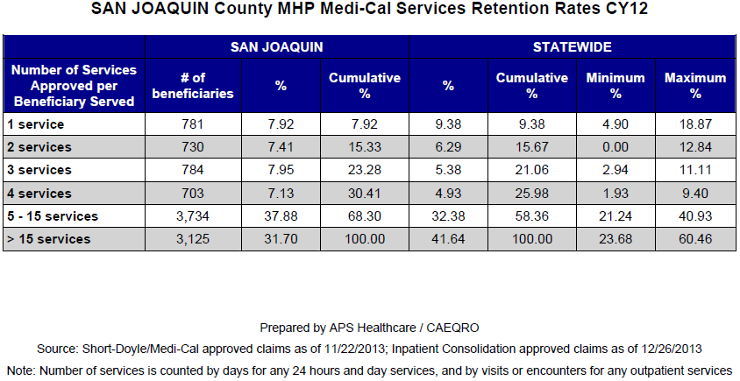
12. Do you think your county is doing a good job at keeping clients engaged in services? If yes, how? If not, why?
San Joaquin has proportionately fewer Medi-Cal beneficiaries receiving only one or two service per year than the state average. Here we are doing a relatively good job. Retention beyond 15 services is less than the state average, but well beyond the state minimum. BHS could improve retention for those who receive greater than two services.
The table above provides retention rates for approved Medi-Cal recipients only. BHS also provides services to non-recipients, and BHS data suggests that retention rates are higher for all service recipients.

13. For those clients receiving less than 5 services, what is your county doing to follow-up and re-engage those individuals for further mental health services?
Via the InSPIRE project, which started in 2014, BHS is emphasizing its outreach and engagement efforts to hard-to-engage, high-frequency users of crisis services. BHS staff recognize that it is necessary for staff to “meet people where they are at” over and over, until they develop trust. The InSPIRE Project provides intensive, assertive outreach to those who typically say “no” to outpatient supports, and as a result end up in involuntary placement. There are currently 17 individuals whom BHS staff members have identified as needing extra engagement. The goal is to make contact with them every day, help them meet basic needs such as food, hygiene, and housing, to remind them that behavioral health services are available, and to build trust so that they are open to ongoing services and supports.

14. Looking at the previous chart of who is being served by race/ethnicity in your county, do you have any thoughts or ideas to share regarding your county’s engagement of underserved communities?
Community leaders and other stakeholders need to be identified among each underserved group. Help generate awareness of services by presenting to faith organizations and community groups. Reach out to underserved communities rather than waiting for them to proactively call.
CLIENT OUTCOMES: Consumer Perception Survey (August 2013)
Ultimately, the reason we provide mental health services is to help individuals manage their mental illness and to lead productive lives. We have selected two questions from the Consumer Perception Survey which capture this intention. One question is geared toward adults of any age, and the other is for children and youth under 18.
Below are the data for responses by clients in your county to these two questions.
For general comparison, statewide reference data for various sized counties are shown in the tables on page 19.
The total numbers of surveys completed for Adults or Children/Youth in your county are shown separately in the tables below, under the heading “Total.”

Q1. Adults. As a direct result of the services I received, I deal more effectively with daily problems.
 | Strongly Disagree | Disagree | Neutral | Agree | Strongly Agree | Total
Number of Responses | 4 | 20 | 68 | 178 | 142 | 412
Percent of Responses | 1.0 % | 4.9 % | 16.5 % | 43.2 % | 34.5 % 76.7 | 100.0 %

Q2. Children/Youth. As a result of services my child and/or family received, my child is better at handling daily life.

 | Strongly Disagree | Disagree | Neutral | Agree | Strongly Agree | Total
Number of Responses | 4 | 9 | 24 | 70 | 15 | 122
Percent of Responses | 3.3 % | 7.4 % | 19.7 % | 57.4 % | 12.3 % 69.7 | 100.0 %

15. Are the data consistent with your perception of the effectiveness of mental health services in your county?
These figures are not inconsistent with BHS’s perception of service effectiveness. However, there is insufficient information from the data presented to determine if this is a representative sample of BHS clients. We understand, also, that there were other questions asked of the clients, but have not yet seen results or sample distributions.
BHS administers an independent client satisfaction survey annually. This survey received 876 compared to 534 responses (319 child versus 122 child responses). This survey found that 92% of respondents “like the services I receive here”. Ninety-four (94%) of parents of children 0-18 reported that they like the services they receive.
16. Do you have any recommendations for improving effectiveness of services?
See question 18 below.
17. Many counties experience very low numbers of surveys completed. Do you have suggestions to increase the response rate?
The survey is very long; perhaps it could be shorter. BHS asks only eight Likert scale questions on its survey.
18. Lastly, but perhaps most important overall, with respect to delivery of services, do you have suggestions regarding any of the following:
- Specific unmet needs or gaps in services:
Pharmacy hours limited to typical business hours (Monday-Friday, 8-5). Also, a newly-awarded CHFFA grant will enable BHS to renovate and expand the crisis stabilization unit, allowing for both voluntary and involuntary stabilization and a separate entrance for children. The addition of Mobile Crisis Response Teams will help meet demand from the community and law enforcement.

- Improvements to, or better coordination of, existing services: Continue to provide mental health trainings, including Mental Health First Aid, to community partners via train-the-trainer model. Enhance and refer dual-diagnosed clients to programs that address substance use and mental health. Provide drug detoxification information on the county website, and information on what insurances detoxification programs currently accept. Provide caregivers who have conservatorship an on-line list of housing vacancies.

- New programs that need to be implemented to serve individuals in your county: Stakeholders want long-term, stable and affordable supportive housing with onsite clinician, medication administration, support for families, and engaging activities. Offer GED programs to clients, including those with dual diagnosis. GED programs can be offered at the Wellness Center or BHS main campus. Offer recreation and fitness programs, including bowling nights, fishing days, walking in the park, museum nights and movie days. Hire an activities director to coordinate weekly activities throughout the county.
REFERENCE DATA: for general comparison with your county MHP results
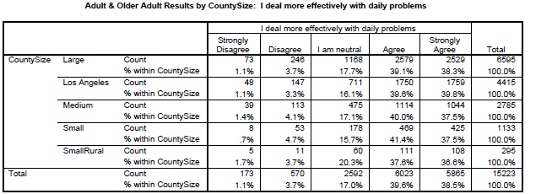

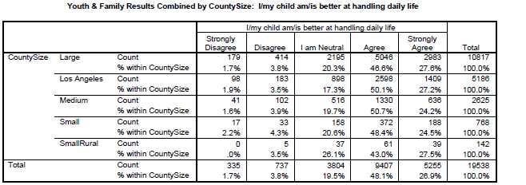
County Mental Health Plan Size: Categories are based upon DHCS definitions by county population.
o Small‐Rural MHPs = Alpine, Amador, Calaveras, Colusa, Del Norte, Glenn, Inyo, Lassen, Mariposa, Modoc, Mono, Plumas, Siskiyou, Trinity
o Small MHPs = El Dorado, Humboldt, Imperial, Kings, Lake, Madera, Mendocino, Napa, Nevada, San Benito, Shasta, Sutter/Yuba, Tehama, Tuolumne
o Medium MHPs = Butte, Marin, Merced, Monterey, Placer/Sierra, San Joaquin, San Luis Obispo, San Mateo, Santa Barbara, Santa Cruz, Solano, Sonoma, Stanislaus, Tulare, Yolo
o Large MHPs = Alameda, Contra Costa, Fresno, Kern, Orange, Riverside, Sacramento, San Bernardino, San Diego, San Francisco, Santa Clara, Ventura
o Los Angeles’ statistics are excluded from size comparisons, but are included in statewide data.
Total Values (in Tables above) = include all statewide data received by CiMH for these survey items.

REMINDER:

Thank you for your participation in completing your Data Notebook report.
Please feel free to provide feedback or recommendations you may have to improve this project for the following year. We welcome your input.

Please submit your Data Notebook report by email to:
DataNotebook@CMHPC.CA.GOV

Or, you may submit a printed copy by postal mail to:
- Data Notebook Project
- California Mental Health Planning Council
- 1501 Capitol Avenue, MS 2706
- P.O. Box 997413
- Sacramento, CA 95899-7413

For information, you may contact either email address above, or telephone:
(916) 449-5249, or
(916) 323-4501

Serious Mental Disorder, term used for adults 18 and older.
Severe Emotional Disorder, term used for children 17 and under.

