Marin County: Data Notebook 2014
for California
Mental Health Boards and Commissions
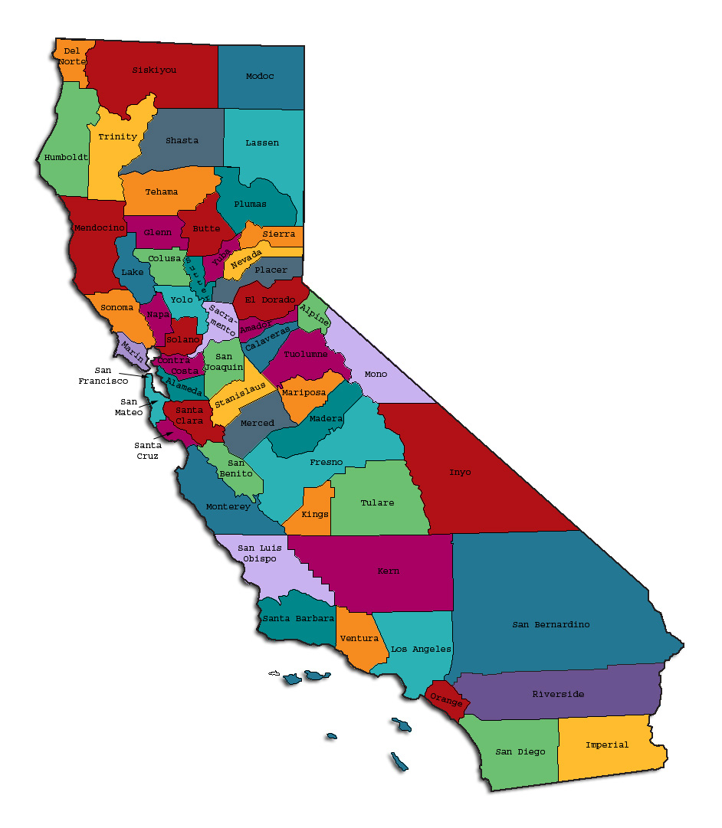
Prepared by California Mental Health Planning Council, in collaboration with: California Association of Mental Health Boards/Commissions, and APS Healthcare/EQRO
This Page Intentionally Left Blank.
Date: April 20, 2014
To: Chairpersons and/or Directors
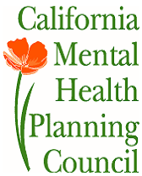
Local Mental Health Boards and Commissions
From: California Mental Health Planning Council
Subject: Instructions for Data Notebook 2014

We ask that this report be prepared by the MH Board or Commission members. You are the most important resources for identifying program strengths and needs in your community.
On the first page, please fill in the requested information for your county websites:
- Department of Behavioral Health/ Mental Health
- Public reports about your county’s MH services.
Please send a copy of the filled-in first page to the Planning Council along with your final report which contains your answers to the questions in the Data Notebook. Please submit your report within 60 days by email to:
DataNotebook@cmhpc.ca.gov.
Or, you may mail a printed copy of your report to:
- Data Notebook Project
- California Mental Health Planning Council
- 1501 Capitol Avenue, MS 2706
- P.O. Box 997413 Sacramento, CA 95899-7413
Please examine the enclosed information, which will help you discuss the questions in the Data Notebook. We provide examples of recent mental health data for your county. In some figures, the term “MHP” is used to refer to your county’s Mental Health Plan.
Some data comes from APS Healthcare/EQRO, which gave permission to use their figures and tables, prepared for review of each county’s Medi-Cal Specialty Mental Health services. Data in this packet came from the following review cycle:
__X__ Fiscal Year 2013 -- 2014: http://caeqro.com/webx/.ee85675/
_____ Fiscal Year 2012 -- 2013: http://caeqro.com/webx/.ee851c3/
For some questions, you will need to consult your local county Quality Improvement Coordinator, and/or Mental Health Director. If you are not able to address all of the questions, just answer the ones you can.
Thank you for your participation in the Data Notebook Project.
This Page Intentionally Left Blank

Marin County: Data Notebook 2014
for California
Mental Health Boards and Commissions

County Name: Marin Population (2013): 255,887
Website for County Department of Mental Health (MH) or Behavioral Health:
Marinhhs.org
Website for Local County MH Data and Reports:
Marinhhs.org
Website for local MH Board/Commission Meeting Announcements and Reports:
//www.marinhhs.org/boards/marin-county-mental-health-board
Specialty MH Data from review Year 2013-2014: http://caeqro.com/webx/.ee85675
Total number of persons receiving Medi-Cal in your county (2012): 29,132
Average number Medi-Cal eligible persons per month: 23,998
Percent of Medi-Cal eligible persons who were:
Children, ages 0-17: 39.7 %
Adults, ages 18-59: 44.0 %
Adults, Ages 60 and Over: 16.3 %
Medi-Cal beneficiaries persons with SMI or SED who received Specialty MH services (2012): 1,802
Percent of Specialty MH service recipients who were:
Children 0-17: 30.1 %
Adults 18-59: 52.4 %
Adults 60 and Over: 17.5 %

This Page Intentionally Left Blank
INTRODUCTION: Purpose, Goals, and Data Resources
This Data Notebook has been developed for the use by the local mental health (MH) boards and commissions by a yearlong workgroup comprised of members from:
- California Mental Health Planning Council (CMHPC)
- California Association of Local Mental Health Boards and Commissions (CALMHB/C)
- APS Healthcare/ EQRO (External Quality Review Organization)
Our plan is for the Data Notebook to meet these goals:
- assist local boards to meet their mandates to review the local county mental health systems, identify unmet needs, and recommend improvements.
- provide a professional format for submitting reports to their local Board of Supervisors, and/or their county Director of Mental Health Services.
- function as an educational tool for local boards, whose members have varying levels of skills, frequent turnover, and need ‘refresher’ training about using data.
- help the CMHPC fulfill its mandates to review and report on the public mental health system in California, which also helps provide evidence for advocacy.
Data reporting drives policy, and policy drives funding for programs. But the data must be both recent and available to the public, or else it is not useful. So, the CMHPC will provide examples of local data from current public reports. We focus on two broad areas: (1) evaluation of program performance, and (2) indicators of client outcomes.
We recognize that each county has a unique population, resources, strengths, and needs. Thus, there is no single perfect data source to answer all the important questions one might ask about mental health services. However, the following data resources will help board members answer questions in this Data Notebook:
- experience and opinions of the local mental health board members
- recent reports about county MH programs from APS Healthcare/EQRO
- data you request from your county QI Coordinator and/or Mental Health Director (because CMHPC does not have that data, and it’s not in other public reports)
- client outcomes data provided by California Institute of Mental Health (CiMH) in their analysis of the most recent Consumer Perception Survey.
Some of our data comes from APS Healthcare/EQRO, which kindly gave permission to use their figures and tables, prepared for review of each county’s Medi-Cal Specialty Mental Health services. Those reviews are at: www.CAEQRO.com. You may find the full-length EQRO reports helpful because they summarize key programs and quality improvement efforts for each county. They also describe strengths, opportunities for improvement, and changes in mental health programs since the last year.
Understanding changes in local programs can help consumers because of the massive re-organization of mental health services statewide. Some changes have been confusing to clients. The old state Department of Mental Health was eliminated in 2012 and many functions were moved to the Department of Health Care Services. Other changes due to federal health care reform and the Affordable Care Act affect how mental health services are provided, funded, and linked to primary health care or substance use treatment. Also, local counties have adjusted to major challenges.
Remember, this report is about your community, and what you and your stakeholders choose to discuss. Examining the data can indeed “Tell a Human Story.” But quantitative data (numbers) provides only part of the picture, for example:
- measures of whether the quality of program services improve over time
- whether more people from different groups are receiving services
- how many clients got physical healthcare or needed substance use treatment.
The other part of the story gives human context to the numbers. Such qualitative data (narrative, descriptions, or stories) tells more of the story, because we can:
- describe special programs targeted for outreach to specific groups
- examine how the programs are actually implementing their goals
- list concrete steps that are taken to improve services, and
- tell what is being done to increase client engagement with continued treatment.
We hope this project contributes to ongoing quality improvement (QI) in mental health services. We seek constant improvement in our approach to quality because:
- needs change over time,
- all human endeavors are by nature imperfect,
- creativity gives rise to new ideas, and
- we can share examples of successful programs to help other communities.
One question is whether local boards are permitted to provide additional information, besides that requested in this Notebook. We always welcome supplemental reports about successful projects, or which the county administration uses to inform the public. Any additional reports may be attached in an “Appendix,” with the website address (if available). However, we emphasize such extra reports are not required.
Thank you for participating in this project. We hope this Data Notebook serves as a springboard for your discussion about all areas of the mental health system, not just those topics highlighted by our questions.
TREATING THE WHOLE PERSON:
Integrating Behavioral and Physical Health Care
Studies have shown that individuals with serious mental illness die, on average, 25 years earlier than the general population. This information makes improving the physical health of clients of great importance and should be a goal of county mental health departments along with providing effective and appropriate mental health services. Coordination of care for mental health, substance abuse and physical health is one way of accomplishing the goal.
The California Mental Health Planning Council does not have any data to provide to show how your county’s programs connect clients of mental health services with necessary physical health care. We ask that the local mental health board request information from your county mental health department for any data on numbers (or percent) of total mental health clients who are referred to, or connected with, physical health providers to assess, treat and monitor physical health issues.
If your county has data on numbers or percentages of clients who are also receiving physical health care, please include it in your Data Notebook you submit to the Council.
__X_ Check here if your county does not have such data or information.

1) Please describe any efforts in your county to improve the physical health of clients.
Marin County’s Division of Mental Health and Substance Use Services (MHSUS) utlizes a variety of methods to provide services that support whole person wellness. Intake to MHSUS services includes an assessment that gathers information regarding a new consumer’s physical health status and connection with primary care and dentistry providers. Clinical and family/peer provider staff utilize group settings to offer a wide variety of wellness opportunities including smoking cessation, meditation, yoga, Zumba, walking and gardening. Supportive living settings sponsor programs that focus on nutrition education, healthy eating and cooking.
The MHP works in conjunction with the local Federally Qualified Health Centers (FQHC) to staff an integrated physical and behavioral health clinic—a clinic which has been in operation since the 1990s. The MHP is working with local suicide prevention staff to implement Suicide Prevention in Primary Care trainings for providers working in the FQHCs.
In Fiscal Year 12-13 MHSUS adopted Stage One of Meaningful Use (MU) for its Mental Health Electronic Health Record (EHR). MU is designed to help health care providers improved treatment, coordination of services and overall outcomes for consumers through tracking and supporting behavioral changes and routine screenings for conditions that are highly responsive to medical intervention.
MHSUS has a very successful smoking cessation program. Several Community Based Organizations (CBOs) offer healthy cooking classes. Unfortunately, in some supportive housing situations it has been reported that healthy eating habits aren't being robustly supported; this remains an important opportunity for future intervention.

2) How does your county address wellness programs to engage and motivate clients to take charge of improving their physical health?
As stated above, the MHP offers wellness activities through a variety of treatment programs including the Latino Family Health Clinic and the consumer-operated Enterprise Resource Center. Current activities include classes in:
- Exercise
- Nutrition
- Healthy cooking
- Stress management
- Quitting smoking
- Managing chronic disease
- Maintaining social connectedness
- Movement
- Meditation/Mindfulness/Yoga

NEW CLIENTS: One Measure of Access
One way to evaluate the quality of mental health services outreach is to measure how many clients receive services who have never been part of the service system before (“brand new” clients). Another measure is how many clients return for services after a period of time with no services (“new” clients).
The California Mental Health Planning Council is exploring how each county mental health department defines “new” clients, and how a client is labelled when they return for additional services. This information is important in determining whether your county has a “revolving door,” that is, clients who are in and out of mental health services repeatedly. This data is one indicator of the success of your county’s programs in closing cases appropriately and providing adequate discharge planning to clients.
This data is not currently reported by the counties to the state. The Council does not have data to provide to you. This information should be requested from your county mental health department.
____ Check here if your county does not have this information.
3. How does your county define 'new' client for those individuals who have previously received services, but who have not received services for a while? (e.g., 6 months, 12 months, 2 years?)
The definition of “new client” varies by program and ranges from six months (for FSPs) to 12 months (all other services).

4. Please provide any data your county has on the number of 'new' clients last year. And if you have it, how many of those new clients were brand new clients? You may need to ask your county mental health department for this data.
The MHP provided services to 829 “brand new” clients in CY13-14.
REDUCING RE-HOSPITALIZATION: Access to Follow-up Care
Sometimes, an individual experiences acute symptoms of mental illness or substance abuse which can result in a brief stay in an acute care hospital. Receiving follow-up services after discharge from a short-term (3-14 day) hospitalization can be critical to preventing a return to the hospital.
The chart below shows the percentage of people discharged in your county who received at least one service within 7 days of discharge. Also shown is the percentage of those same people who were readmitted to the hospital. The chart also shows the same information for receiving services and being readmitted to the hospital within 30 days. Blue indicates the percentages for events or services within seven days and the red indicates the percentage for events or services within 30 days.

Marin County:
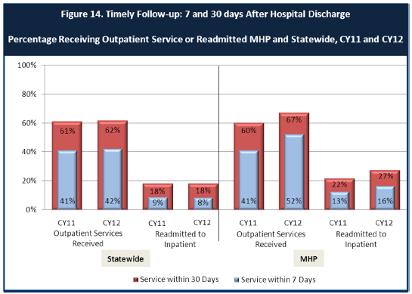

6. Looking at the chart, is your county doing better or worse than the state? Discuss why (e.g., your county has programming available that specifically ensures a warm handoff for follow-up services).
MHSUS provides an equivalent percentage of services at seven days and a higher percentage of services at thirty days than the state in terms of our outpatient services, however the readmission rates are higher. We believe this may be a lack of case managers, particularly peer case managers to help the consumer navigate the system. Also, although hospital practices vary, it is not uncommon for hospitals to discharge consumers with less medication than they need to bridge the time until they are able to receive a psychiatry service. Readmissions may be compounded by the complexity of the system and the many different departments and agencies that serve the consumer population. Poor public transportation creates another barrier for consumers to make their appointments after hospitalization and may also be leading to greater readmission rates.
7. Do you have any suggestions on how your county can improve follow-up and reduce re-hospitalizations?
Increasing the number of case managers, particularly peer case managers for warm handoffs and follow up for PES and hospital discharge to ensure that all consumers are adequately case managed. Offering bus vouchers to patients to assist them in getting to appointments, and getting home after hospitalization would also be beneficial.

8. What are the three most significant barriers to service access? Examples:
- Transportation
- Child care
- Language barriers or lack of interpreters
- Specific cultural issues
- Too few child or adult therapists
- Lack of psychiatrists or tele-psychiatry services
- Delays in service
- Restrictive time window to schedule an appointment

1. Lack of community engagement with the Latino community.
2. Lack of peer providers.
3. Delays in service.
4. Transportation.
5. Too few child or adult therapists. (Peer Case Managers)

ACCESS BY UNSERVED AND UNDER-SERVED COMMUNITIES
One goal of the Mental Health Services Act (MHSA) is to reach unserved and underserved communities, especially communities of color. The MHSA promotes outreach to engage these communities in services. If individuals and families in these communities are not accessing services, then we may need to explore new ways of reaching them. Or, we may need to change our programs to meet their mental health needs in ways that better complement their culture.
From data the counties report to the state, we can see how many individuals living in your county are eligible for Medi-Cal, and of those individuals, how many received mental health services. Are you serving the Medi-Cal clients who need your services?
Marin County:
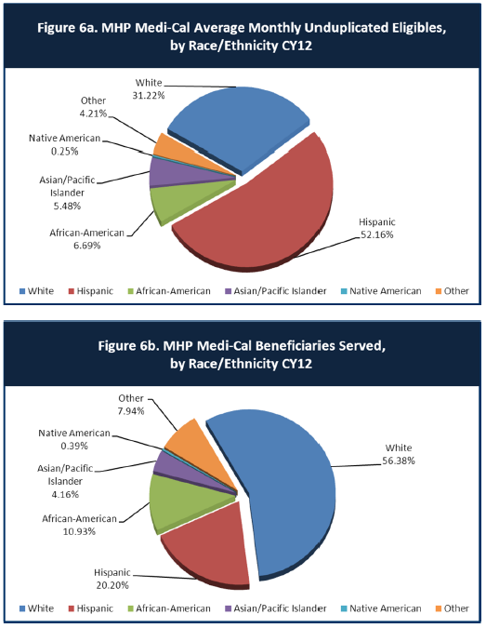
9. Is there a big difference between the race/ethnicity breakdown on the two charts? Do you feel that the group(s) that need services in your county are receiving services?
Latino Medi-Cal beneficiaries are served at a disproportionately lower rate compared to their overall numbers in the county. This seems to be particularly the case in the adult system, since over 64% of the consumers receiving youth and family services self-identify as Latino. While this low penetration rate for adults may in part be because of cultural differences, we feel it is also because of the structure of our service continuum, which has a ways to go to be culturally competent.
10. What outreach efforts are being made to reach minority groups in your community?
We have been addressing this problem with a variety of methods. A large reason we are behind is because for a very long time with we did not have a permanent Ethnic Services Manager (ESM), with the person in that role serving in an interim capacity. Lack of permanence in that position creates a huge gulf between ourselves and properly serving our communities of color. Now that the ESM position has now been permanently filled, outreach efforts are being made on a consistent basis. The ESM conducts weekly field visits to ethnic communities such as Marin City and the Canal neighborhood, the two largest ethnic communities (African American and Latino respectively ) in Marin County, to meet with community leaders, agency leaders and residents on a host of subjects related to mental and substance use-related policies, services, programs and resources. Additionally, the ESM attends monthly service providers’ collaborative meetings in rural West Marin to provide updates and announcements on MHSUS programs, activities, events and other pertinent state-wide, regional and local initiatives, trends and emerging issues. Lastly, the ESM attends approximately 3-5 community public meetings, gatherings and events per month throughout the county where there is a high participation of communities of color and under-represented groups. The overall purpose of all outreach efforts undertaken by the ESM is to provide under-represented communities ongoing opportunities to express their needs, hopes, concerns and ideas, and to share this body of information to the division director and senior management.
Results of these activities led the MHP to develop multiple action steps that address promoting or increasing strategies to reduce stigma and discrimination including:
- Continued development of the existing Cultural Competence Advisory Board in the central and remote areas of Marin.

- Improve phone language lines by installing bilingual (Spanish) outgoing and incoming messages; increase the number of Spanish speaking staff at PES and in adult services.

- Continue to outreach to and engage underserved and un‐served Latino community (residents, agency providers and Latino‐run organizations/institutions) for increased partnerships and collaboration.

- Continue the Latino Family Health Clinic and Vietnamese Family Health Clinics that provide a variety of services to both Medi-Cal beneficiaries and those without insurance benefits.
- Maintain MHSUS existing and proven best‐practice programs that serve the Latino community (i.e. Promotores, Youth Empowerment Services and Youth Development and Leadership Program and Family Partnership programs).

- Deploy Spanish speaking mental health staff and establish satellite offices at Latino‐run organizations such as the Canal Alliance, Parent Services Project, and the Canal Welcome Center for the purpose of improving penetration rates and access .

- Explore increased collaboration with neighborhood schools in predominantly Latino communities through initiatives such as the “Community School Model” approach.

11. Do you have suggestions for improving outreach to and/or programs for underserved groups?
Greater community engagement is foremost. Engaging the community destigmatizes, and turns community member into referrers and helpers in their own way.

CLIENT ENGAGEMENT IN SERVICES
One MHSA goal is to connect individuals to services they need to be successful. Clients who stop services too soon may not achieve much improvement, nor is it likely to last. So it is important to measure not only who comes in for treatment, but also how long they stay in services. Here we are considering individuals with high service needs, not someone who just needs a ‘tune-up.’ Although not every individual needs the same amount of services, research shows that when someone with severe mental illness continues to receive services over time, their chances of recovery increase.
Engagement in services, also called ‘retention rate’, is important to review. If individuals come in, receive only one or two services and never come back, it may mean the services were not appropriate, or that the individual did not feel welcome, or some other reason that should be explored. Again, we recognize that some individuals only need minimal services, but here we are looking at those with severe mental illness. Ultimately, the goal is to ensure they are getting needed services and are on the road to recovery. But we would not know that unless we look at how many services individuals received over time.
The chart below shows the number of Medi-Cal beneficiaries in your county who received 1, or 2, or 3, or 4, or 5, or more than15 mental health services during the year. For individuals experiencing severe mental illness, the more engaged they are in services, the greater the chance for lasting improvements in mental health.

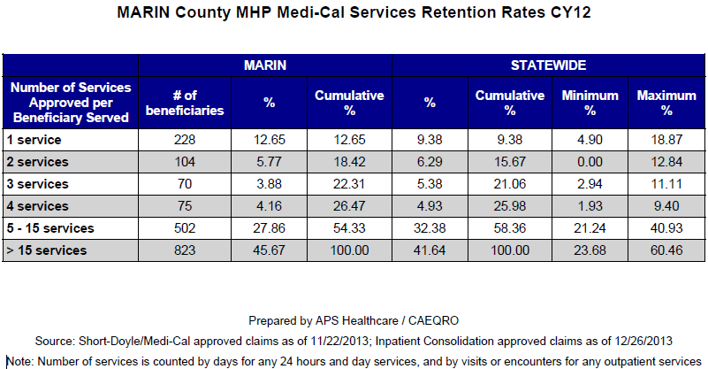
12. Do you think your county is doing a good job at keeping clients engaged in services? If yes, how? If not, why?
It depends on the context of age, race, and socio-economic status. We seem to do a poorer job at keeping our clients of color within the fold of services. We do an excellent job with our seniors, though we do not know how this breaks down by race. Young people, particularly TAY, are not strongly engaged. Indeed, minors who are under the age of 13 are not given State satisfaction surveys (POQI) per the survey instructions. These are instead given to their parents - which means they have almost no voice in reviewing our services—although it is important to note that children as well as their families are actively engaged in planning their own treatment. There are many different points of this nature, so a deeper look into outcome data is needed.

13. For those clients receiving less than 5 services, what is your county doing to follow-up and re-engage those individuals for further mental health services?
We are not sure what we are doing in this regard. We need more peer case managers; that is certain. It seems it is easy for folks to slip through the cracks.

14. Looking at the previous chart of who is being served by race/ethnicity in your county, do you have any thoughts or ideas to share regarding your county’s engagement of underserved communities?
Engagement may need to happen at a larger scale than just the MHP. There is endemic lack of engagement throughout the county, which could be remedied by a foray into improving the ethnic representations on county advisory boards (external to the MHP) and other bodies.
CLIENT OUTCOMES: Consumer Perception Survey (August 2013)
Ultimately, the reason we provide mental health services is to help individuals manage their mental illness and to lead productive lives. We have selected two questions from the Consumer Perception Survey which capture this intention. One question is geared toward adults of any age, and the other is for children and youth under 18.
Below are the data for responses by clients in your county to these two questions.
For general comparison, statewide reference data for various sized counties are shown in the tables on page 19.
The total numbers of surveys completed for Adults or Children/Youth in your county are shown separately in the tables below, under the heading “Total.”

Q1. Adults. As a direct result of the services I received, I deal more effectively with daily problems.
 | Strongly Disagree | Disagree | Neutral | Agree | Strongly Agree | Total
Number of Responses | 2 | 5 | 31 | 64 | 83 | 185
Percent of Responses | 1.1 % | 2.7 % | 16.8 % | 34.6 % | 44.9 % | 100.0 %

Q2. Children/Youth. As a result of services my child and/or family received, my child is better at handling daily life.

 | Strongly Disagree | Disagree | Neutral | Agree | Strongly Agree | Total
Number of Responses | 2 | 1 | 4 | 26 | 12 | 45
Percent of Responses | 4.4 % | 2.2 % | 8.9 % | 57.8 % | 26.7 % | 100.0 %

15. Are the data consistent with your perception of the effectiveness of mental health services in your county?
Among adults 79.5% agreed or strongly agreed that the services were helpful in increasing the ability to cope with daily problems. Among youth and families of children, 84.5% agreed or strongly agreed with that statement. However we are sad to see the high neutrality of clients. We hope they could have a more cathartic experience with our services. Also, we wonder why for so many we do not quite hit the threshold of strong affirmations for the services. What is holding us back?
Very importantly, we need to give minors surveys to gauge what their perceptions of our services are.

16. Do you have any recommendations for improving effectiveness of services?
We believe that improving our cultural competency and increasing the number of peer workers are salient needs. More case managers are also needed to improve connectedness and follow through.
For engaging with young consumers, it is necessary to explore how ageism and its implications are impacting how consumers are moving forward within their lives and in the community. The cultural stigma that young people are inherently incompetent needs to be challenged in our own continuum of care, and there must be greater young stakeholders utilized.

17. Many counties experience very low numbers of surveys completed. Do you have suggestions to increase the response rate?
The MHP typically has a high response rate to the POQI—with 381 responses received for the most recent administration. The MHP benefits from the assistance of peer providers who assist consumers who could use support with survey completion.

18. Lastly, but perhaps most important overall, with respect to delivery of services, do you have suggestions regarding any of the following:
- Specific unmet needs or gaps in services

- Improvements to, or better coordination of, existing services

- New programs that need to be implemented to serve individuals in your county

In the context of PES, we believe that follow up may be a weakness in service as indicated by the services provided chart and the high readmission rate. Peer case managers can be an important part of helping consumers and families navigate what appears to be a very complex system. An improved system of increasing peer case management and communication between police departments, CBO's and the community could be of value in addressing improvements to and better coordination of services.
Through and through, meaningful engagement with Latino communities should be a salient concern, along with our continued integration of cultural competency into our services.
Also, we see strong connection with the Marin Police departments to be of vital concern for MHSUS. It is important of this connection at all levels could improve outcomes for individuals with mental health and substance use issues.

<END>

REFERENCE DATA: for general comparison with your county MHP results

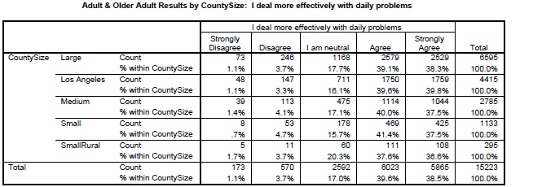

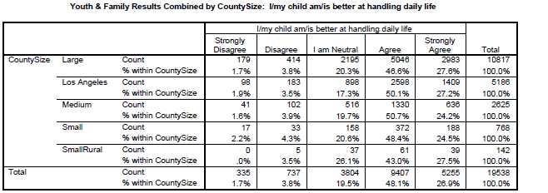

County Mental Health Plan Size: Categories are based upon DHCS definitions by county population.
o Small‐Rural MHPs = Alpine, Amador, Calaveras, Colusa, Del Norte, Glenn, Inyo, Lassen, Mariposa, Modoc, Mono, Plumas, Siskiyou, Trinity
o Small MHPs = El Dorado, Humboldt, Imperial, Kings, Lake, Madera, Mendocino, Napa, Nevada, San Benito, Shasta, Sutter/Yuba, Tehama, Tuolumne
o Medium MHPs = Butte, Marin, Merced, Monterey, Placer/Sierra, San Joaquin, San Luis Obispo, San Mateo, Santa Barbara, Santa Cruz, Solano, Sonoma, Stanislaus, Tulare, Yolo
o Large MHPs = Alameda, Contra Costa, Fresno, Kern, Orange, Riverside, Sacramento, San Bernardino, San Diego, San Francisco, Santa Clara, Ventura
o Los Angeles’ statistics are excluded from size comparisons, but are included in statewide data.
Total Values (in Tables above) = include all statewide data received by CiMH for these survey items.

REMINDER:

Thank you for your participation in completing your Data Notebook report.
Please feel free to provide feedback or recommendations you may have to improve this project for the following year. We welcome your input.

Please submit your Data Notebook report by email to:
DataNotebook@CMHPC.CA.GOV

Or, you may submit a printed copy by postal mail to:
- Data Notebook Project
- California Mental Health Planning Council
- 1501 Capitol Avenue, MS 2706
- P.O. Box 997413
- Sacramento, CA 95899-7413

For information, you may contact either email address above, or telephone:
(916) 449-5249, or
(916) 323-4501

Serious Mental Disorder, term used for adults 18 and older.
Severe Emotional Disorder, term used for children 17 and under.

