**BHB Data Notebook Summary**:

California Mental Health Planning Council has requested the Data Notebook 2016 for Local Mental Health Boards and Commissions be completed for use in reporting to the CMHPC.

The data itself has already been completed and is in the booklet provided. They would like the BHB, CMH and community stakeholders to take a look at the data and use it to evaluate the effectiveness of local Children’s Mental Health by answering specific questions. The BHB Children & Families Subcommittee and DHHS Children’s Mental Health have had several meetings to go over the data and answer the questions.

Highlights:

Humboldt County penetration rates (the percentage of people who are eligible for Medi-Cal who received mental health services) are better than other small counties and California as a whole. This is true of every age range and ethnicity, with the exception of Asian/Pacific Islander.

Humboldt County Transition Age Youth Collaborative (HCTAYC) and TAY is a great program that integrates and connects youth to many types of services and providers. It can serve as a model for consumer and stakeholder involvement for other populations. It would be great to expand their staffing and space. There is also still a need for development of services and supports for the LGBTQ TAY population.

The Family Advisory Board (FAB) has begun meeting. It is still in its infancy, but has the potential to develop into a great tool for family engagement and empowerment.

Children’s Mental Health has started providing services and engagement in the field. Families no longer need to travel long distances in order to see a mental health clinician. Already, the results have been great, although there is still room for growth.

The data book questions are in ten areas:

1. **Access: Outreach and Engagement (p. 13-17)**

**Race Distribution of those who received Specialty Mental Health Services**

**(FY 13-14)**



**Service Penetration Rates for Children/Youth Receiving at least one MH service/year**

**(FY13-14)**



**Service Penetration Rates for those Receiving at least 5 or more MH Services/Year**

**(FY13-14)**

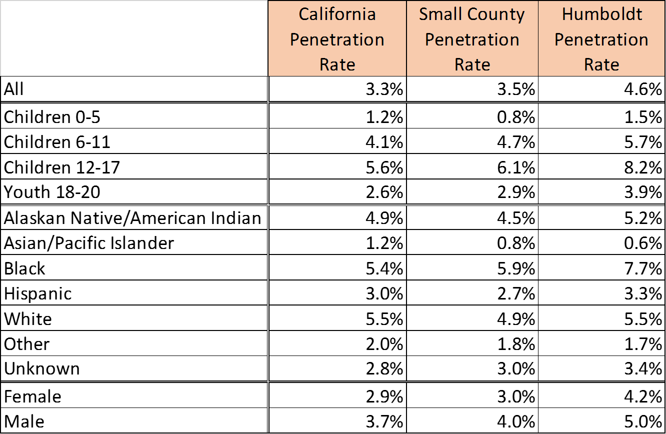

**A. Do you think the county is doing an effective job providing access and engagement for children and youth in all of your communities? If yes, what strategies seem to work?**

As a rural county it is difficult to engage and promote access for children and youth in the remote areas of the county. We are working on this issue. Here are some strategies we are beginning to use:

* Several units and EBPs offer services throughout the county with staff regularly providing services in the field, homes, and schools.
* Continued partnering with Probation, Child Welfare Service (CWS), Family Resource Centers (FRCs), and schools helps to identify, engage, and provide services to youth and families who would benefit from county services.
* Enabling staff to be mobile and flex hours helps to remove barriers to engagement and include family members in treatment.

Areas of need:

* Workforce that is qualified to serve young children
* Consistent linkages staff in schools.
* Reduce stigma of working with County in Eastern and Southern Humboldt
* Engage parents as partners
* Support for families of young children

**B. What strategies are directed specifically towards outreach and engagement of transition-aged youth in your county? Please list or describe briefly.**

* A dedicated TAY unit which enables staff to specialize in working with TAY youth
* Drop-in hours which encourage the engagement of youth who are interested in services
* Co-location of TAY Behavioral Health Services, Extended Foster Care and Independent Living Skills (ILS) promotes communication and cross-referrals
* Input from Humboldt County Transition Age Youth Collaborative (HCTAYC) which gives a youth voice
* Youth Service Bureau’s RAVEN Project provides street outreach to homeless youth

**C. Do you have any recommendations to improve outreach or services to specific ethnic or cultural groups of adolescents or transition-aged youth? If yes, please list briefly.**

* Increased regionalization would enable staff to be located and work regularly in rural areas of the county, develop relationships within those communities, and reduce barriers to engaging in services
* Additional Spanish speaking clinicians and case managers are needed
* Increase culturally appropriate services, based not only on regions and ethnicity, but LGBTQ as well
* Increase diversity of staff and Behavioral Health Board members
* Build relationships between Department of Health and Human Services (DHHS), Education, Family Resource Centers, and Tribes
* Offer targeted services for young parents
* Increase capacity of TAY division (staff and space)
* Facilities in rural areas, such as Hoopa, Ferndale, and Southern Humboldt

**D. What are your main strategies for assisting parents/caregivers of children with mental health needs? Please list or describe briefly**.

* Field based engagement by clinicians and case managers
* Smooth access to an assessment and referrals to the appropriate level of service
* A wide array of services enable parents/caregivers to find the treatment that works for their family
* Parent Partners are also available to specifically support and assist parents/caregivers of children with mental health needs

2. **Access: Timely Follow-Up Services after Child/Youth Psychiatric Hospitalization (p. 19-20)**

**A. Do you think your county is doing an effective job providing timely follow-up services after a child or youth is discharged from a mental health hospitalization? If no, please describe your concerns or recommendations briefly.**

Humboldt County has no Psychiatric Hospital for children/youth. When children/youth require hospitalization for mental health services, they must be sent to a facility outside of the county.

* Recent Performance Improvement Plan was completed to reduce time from Crisis Stabilization Unit (CSU) discharge to first service. Youth that are placed out of county or hospitalized continue to receive Child and Family Team meetings to coordinate services and prepare for discharge.
* We struggle to follow up with non-Medi-Cal clients (about 10% of CSU clients)

**B. After a hospitalization or MH crisis, what are the main strategies used to engage and ensure prompt follow-up for outpatient care in transition-aged youth? Please list briefly.**

* Mobile Response Team (MRT) is available at the time of CSU or Emergency Room visit. The team helps to develop discharge planning and connect with appropriate services.
* Adult services contacts Children’s Mental Health whenever a youth is presenting at CSU/Same Day Services so a Children’s staff can be sent to assist.
* TAY Peer Coach is available to meet with client to facilitate access to services.

**C. What are the main strategies used to help parents/caregivers of children access care promptly after a child’s hospitalization or other mental health crisis? Please list briefly.**

* Improved discharge planning form and streamlined process.
* MRT can assist with discharge planning and can ensure a follow-up appointment is scheduled.
* Urgent appointments are offered to any client seen by the MRT.
* MRT Clinician follows up with family after discharge to ensure a warm hand-off.

**D. The follow-up data are based on services billed to Medi-Cal. As a result, those data do not capture follow-up services supported by other funding sources. Examples may include post-hospitalization transportation back to the county, contact with a Peer/Family Advocate, or MHSA-based services.**

**Please list some non-Medi-Cal funded strategies your county may use to support families/caregivers following a child’s hospitalization or other MH crisis.**

* MHSA dollars fund the use of Parent Partners
* Family Resource Centers support families
* CalOES CHAT grant provides services to victims of crime in Eastern Humboldt regardless of insurance status
* Support groups are provided by NAMI
* Private insurance can be used to see County Psychiatrist

3. **Vulnerable Groups with Specialized Mental Health Needs: Foster Children and Youth (p. 22-24)**

**Percentage of Foster Care Youth receiving Specialty Mental Health Services**

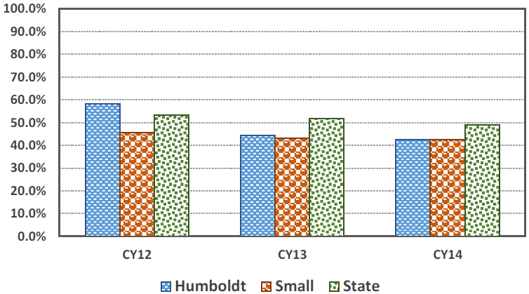

**A. What major strategies are used in your county to provide mental health services as a priority for foster youth? Please list or describe briefly**

Each child involved in the CWS system is screened for MH needs. If a need is identified, the youth will be assessed and referred for the appropriate level of service. A dedicated Child Welfare Behavioral Health unit handles screening, assessment, and services for most CWS involved youth. Services include individual/family therapy, case management, Intensive Care Coordination, Intensive Home Based Services, the use of several Evidence Based Practices (EBPs), and referrals to medication management as needed.

**B. Do you think that your county does a good job of coordinating with your county department of social services or child welfare to meet the MH needs of foster care children and youth? If no, explain briefly.**

We do a fairly good job. CWS and CMH are integrated under Children & Family Services. This enables the two departments to coordinate and team with one another to serve families. CWS and CMH staff at various levels regularly coordinate through Child and Family Team meetings, Interagency Placement Committee (FIT), Resource Allocation Committee (RAC), and many Inter-Agency meetings***.***

CWS and CMH Deputy Directors are co-located, and there is a plan for all staff to be co-located. This improves communication, although there are still occasional conflicts due to differing focus, perspectives, and mandates.

**C. Do you have any comments or suggestions about strategies used to engage foster youth and provide mental health services? If yes, describe briefly.**

Staff in the Child Welfare Behavioral Health unit primarily provide services in the field, homes, and schools to better engage youth and families and reduce barriers to service. Schedules are also flexible depending on the needs of the family.

There is a need for focused training to allow staff to identify and treat mental health needs in the 0-3 population.

Suggestions from HCTAYC:

* A needs assessment for assigning behavioral health staff and support to foster youth
* Better trainings for Foster Parents regarding Behavioral Health Needs, Trauma, and linkage to services
* Integrated and standardized opportunities for foster youth to explore alternative therapies, such as equine, music, and art therapies.
* Give Native Foster Youth Behavioral Health treatment that includes cultural and spiritual interventions, recognizing that models of Indigenous Wellness are not strictly clinical and must include cultural components from providers well equipped to provide linkage and service.
* If at all possible, have someone from a similar lived experience as the child/youth be the one to provide any clinical services, such as a former foster youth or a member of that person’s tribe.
* Giving Foster Youth a choice in receiving psychotropic medications
  + Be transparent to foster youth regarding psychotropic medications
  + Medication should happen in the least intrusive, smallest amount possible
  + Ensure that side effects are communicated to foster parents or other placements
  + Ensure the response to any negative behavioral/affective changes that are the result of a medication is not a higher dose or the addition of another medication
* Ensure that all behavioral health staff serving foster youth is well equipped to understand and assist in the navigation of the Child Welfare System, with access to Child Welfare Staff and Supervisors.
* Behavioral Health treatment should integrate a focus upon the SAMHSA defined 8 Dimensions of Wellness, as trauma is a complex and holistic issue. All treatment should be goal-based and youth driven, working toward assisting young people in developing life-long holistic coping mechanisms
* There should be cultural coaches or experts able to provide direct service and interface with program participants from a variety of lived experiences, such as former foster youth, indigenous peoples, and LGBTQ communities

4. **Vulnerable Groups with Specialized Mental Health Needs: Lesbian, Gay, Bisexual, Transgender and Questioning (LGBTQ) Youth (p. 26)**

**A. Does your county have programs which are designed and directed specifically to LGBTQ youth? If yes, please list and describe briefly.**

* No current programs are specifically designed for LGBTQ youth. All services and EBPs are available to LGBTQ youth.
* The Cultural Competency Committee has offered training on LGBTQ. A policy has been written for interaction with transgender individuals on our outpatient unit.
* TAY provides “Trans-forming Organizations” training to staff

**B. Does your county or community have programs or services designed to improve family acceptance of their LGBTQ youth and/or with the goal of helping to heal the relationship of the youth to his/her family? If yes, please describe briefly.**

Not at this time. In the past, “I am Safe Zone” trainings and “Family Acceptance Project” events have taken place.

**C. Do you have any comments or suggestions about services or how to address unmet needs for LGBTQ youth in your community? If yes, please list or describe briefly.**

* There needs to be LGBTQ Specific Outreach created to ensure that LGBTQ Youth are accessing much needed Behavioral Health Services due to the extreme isolation and invisibilization these youth experience in a rural area.
* There needs to be a focused initiative to increase understanding and acceptance of LGBTQ Youth in Indigenous Communities, as colonization and the western gender-binary have created a hostile environment in Native Communities toward LGBTQ and Two-Spirit People.
* There should be specific Tribal and United Indian Health Services programming for LGBTQ and Two-Spirit Indigenous Youth.
* Comprehensive LGBTQ Acceptance and Inclusivity Trainings should be provided to Behavioral Health Workers and other service providers
* There should be consistent drop-in and community building activities provided to LGBTQ Youth and Young Adults by the County.
* There should be a youth-driven policy recommendation process focusing upon the needs of LGBTQ Youth in Humboldt County.
* LGBTQ Identifiers must be integrated into County Medical Records to ensure that there is data about LGBTQ Youth.
* LGBTQ should be integrated as a focus of cultural competence across all branches of the county government, with particular focus on Behavioral Health. A LGBTQ Specific Work Group for Behavioral Health Cultural Competence should be created that is inclusive of Children’s Services, Transition Age Youth Services, and Adult Services that includes both stakeholder, administration, and subject matter experts.
* A contract with the Family Acceptance Project should be created to guide the development of a Family-Intervention Team to support LGBTQ Youth and Family Struggles.
* An assessment of the overrepresentation of LGBTQ Youth in Foster Care, Juvenile Justice, Homelessness, and Behavioral Health Systems needs to be done. In particular there must be the identification of youth that cross all systems, as federal studies and the limited available local data point toward a significant disparity.
* Questions regarding LGBTQ Identity should be included in all intake processes, and these questions should be developed via stakeholder and subject matter expert involvement.
* There should be clinicians made available in the children’s clinic, TAY, and adult services that are experts in assisting people in identity exploration, in particular those with the ability to assist program participants navigate gender-confirmation therapies and medical treatment.
* The development of culturally defined practices must occur for LGBTQ populations, in particular LGBTQ youth of color, and integrated into the department’s behavioral health practice. This should include the employment of LGBTQ-Identified people of color as Service Providers to serve as Cultural Coaches.

5. **Vulnerable Groups with Specialized Mental Health Needs: Children and Youth affected by Substance Use Disorders (p. 28-30)**

**Numbers of Youth that Began Substance Use Disorder Treatment, FY 2013-2014:**

**California: Statewide**

**Age < 18: 14,957 Age 18-25: 23,614**

**Your County: Humboldt**

**Age <18: 12 Age 18-25: 131**

**A. Does your county provide substance use disorder treatment services to children or youth? If yes, please describe briefly. If no, what is the alternative in your county?**

There are two Substance Abuse Counselors available to provide Substance Use Disorder treatment to youth. The staff use the Adolescent Community Reinforcement Approach (ACRA), and are available to meet with family members as well as youth for outpatient services. The New Horizons program at the Regional Facility (Juvenile Justice) also provides AOD groups as part of the program to all youth that are court ordered to participate. A SUD group was recently started specifically for the TAY age group.

**B. Do you think your county is effective in providing substance use disorder treatment to individuals under the age of 18? Please explain briefly.**

No. In order to be more effective in providing substance use disorder treatment to individuals under the age of 18, a detox facility for minors is needed. This would allow more dual recovery work in our children/youth programs.

We need to build capacity to provide more SUD treatment in our county.

6. **Vulnerable Groups with Specialized Mental Health Needs: Justice System-Involved Youth with Behavioral Health Needs (p. 31-34)**

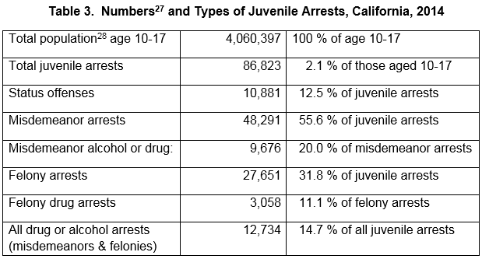

**For State of California: 27,651 juvenile felony arrests, 2014.**

**For Humboldt County: 90 juvenile felony arrests, 2014.**

**A. Does your county provide mental health or substance use disorder treatment services or programs to justice system-involved juveniles while they are still in custody? If yes, list briefly. Please indicate (if available) the main funding sources for these programs.**

* Juvenile Hall – Mental Health Clinicians provide services to youth that are in custody at Juvenile Hall on a weekly basis, or more frequently as necessary. Psychiatric services are also available as needed.
* New Horizons program at the Regional Facility – 4-6 month program for court ordered youth. Program includes MH services, Probation services, and school. EBPs and services used in the program include Aggression Replacement Training (ART), Trauma-Focused Cognitive Behavioral Therapy (TFCBT), AOD groups, Wraparound, individual/family therapy, and case management.

**B. Are the mental health and substance use services provided to non-custodial youth involved with probation or diversion programs different from those services provided to youth in the general community? If yes, please list briefly. Please indicate (if available) the main funding source for these program/services.**

* Services and programs that are offered at the Regional Facility are only available to youth that are court ordered to the program.
* Non-custodial youth can access the full array of MH services.

**C. Do any of these programs engage the parents/guardians of juveniles involved with the justice system? If yes, please list briefly.**

* Family therapy and involvement is a component of the New Horizons program.
* Probation’s Healthy Alternatives program is a court-ordered program that includes Functional Family Therapy. Youth that are ordered to this program must complete FFT to progress through the program and graduate.
* Youth that are involved with the Juvenile Justice system may also be referred to Children & Family Services and can access the full array of MH services.

7. **Mental Health Services Act (MHSA) Programs Helping Children and Youth Recover (p. 35-38)**

**Percentage of High School Students Reporting Thoughts of Suicide, 2011-13**



**A. Does your county have programs that are specifically targeted at preventing suicides in children and youth under 16 (ages 6-16) in your community? If yes, please list and describe briefly.**

* Trainings are offered to staff on suicide and suicide prevention.
* The majority of C&FS staff have gone through the ASSIST training.
* DHHS is participating in the State of Emergency planning in Eastern Humboldt to deal with a high rate of suicide in that area.
* In response to the recently passed California Assembly Bill 2246, local school districts with students in grades 7-12 are working with community stakeholders, Public Health, and Children’s Mental Health to create a guidelines for suicide prevention, intervention, and postvention. The bill requires the policies to specifically address the needs of high-risk youth: youth bereaved by suicide; youth with disabilities, mental illness, or substance use disorders; youth experiencing homelessness or in out-of-home settings; and LGBTQ youth.

**B. Does your county have programs that are specifically targeted at preventing suicides in transition aged youth (ages 16-25) in your community? If yes, please list and describe briefly.**

* TAY staff have also participated in the ASSIST training.
* TAY has participated in “Directing Change Program and Student Film Contest” through Each Mind Matters to produce short films on suicide prevention and mental health stigma reduction.

Public Health has an active Suicide Prevention Program that provides the following trainings:

* Youth Mental Health First Aid: Eight hours of training for adults who work with young people on the risk factors, warning signs and early interventions to help an adolescent in crisis or experiencing mental health challenges
* Applied Suicide Intervention Skills Training: Fourteen hour course in suicide intervention for those most likely to encounter a person at risk for suicide.
* Question-Persuade-Refer (QPR): QPR is a dynamic curriculum that can be adapted to meet the unique needs of any group or organization. It is designed to increase the ability to recognize suicidal thoughts and behaviors, and refer to a professional resource
* Sources of Strength: A youth suicide prevention project that empowers youth voice by creating connections to caring adults to prevent suicide, bullying and substance abuse.

**C. Do you have any further comments or suggestions regarding local suicide reduction/prevention programs? If yes, please list briefly.**

* There is a need for a suicide reduction/prevention EBP tailored to LGBTQ and Tribal youth
* Recently, the Yurok Tribe declared a State of Emergency in regards to the high number of suicides of Tribal people. As a result, a Suicide Prevention Network was formed and meets monthly, with several subcommittees.

8. **Early Identification for First-break Psychosis (p. 39)**

**A. Does your county have services or programs targeted for first break psychosis in children and youth, and transition aged youth (TAY)?**

NAVIGATE program – training for TAY staff for serving first break/first episode youth. Current contract includes re-writing the manual to better target Humboldt’s population.

**B. If yes, please list by age range(s) targeted and describe the program or services briefly. Also, please include the major funding source (i.e., MHSA, SAMHSA Block Grant, Realignment I/II, Medi-Cal, etc.) if the information is readily available.**

NAVIGATE targets youth ages 16-24. It uses a team based approach with the youth, the family, an Individual Resiliency Trainer (illness management and strength building), a Family Education clinician (help family support recovery), and a Supported Employment and Education specialist (pursue employment and treatment goals). It is funded by the Mental Health Block Grant.

**C. Do you have any further comments or suggestions about local programs targeted for first break psychosis in children and youth? If yes, please describe briefly.**

The BHB has a First Break subcommittee that is just getting started*.*

9. **Full service Partnership (FSP) Programs for Children and Youth (p. 40-42)**

**A. What are the most urgent child or youth problems in your county? (For example, homelessness, problems with school or work, arrests, incarcerations, use of emergency MH services or psychiatric hospitalizations, out-of-home placements for children, substance abuse, teen pregnancy/parenting, etc.)**

All of these issues are interrelated and require a holistic approach to improve outcomes for families and children/youth

* **Trauma** 
  + Humboldt among highest ACEs scores in California for all categories
* **Homelessness**
  + Affordable housing shortage in Humboldt
  + Cannot rent without rental history, County DHHS cannot co-sign for families, youths
  + Youths in Extended Foster Care end up couch surfing due to lack of foster parents
* **Suicide**
  + Especially a problem for Tribal youth as highlighted by the Yurok State of Emergency as well as LGBTQ youth
  + Lack of emergency mental health services for children/youth
* **Generational Substance Abuse Issues**
  + Easy access to substances for children/youth
* **Nutrition**
  + Many food deserts
  + Hard for homeless families to prepare healthy food without kitchens
* **Teen pregnancy/parenting** 
  + There currently aren’t any services directed to this population in Humboldt, other than CalLearn

**B. Do the FSP data suggest how (or where) improvements to certain services or programs could affect outcomes, and thereby help address the most urgent problems for children or youth in your community?**

Those TAY that qualify for FSP can be assessed and receive portions of the FSP services although the full spectrum of services is often provided through alternative programs and funding sources.

**C. Do you have any other comments or recommendations regarding your local FSP programs or other types of “wrap-around” services? If yes, please describe briefly.**

We have started providing high-fidelity Wraparound to the highest needs clients.

10. **Data Notebook Questionnaire**

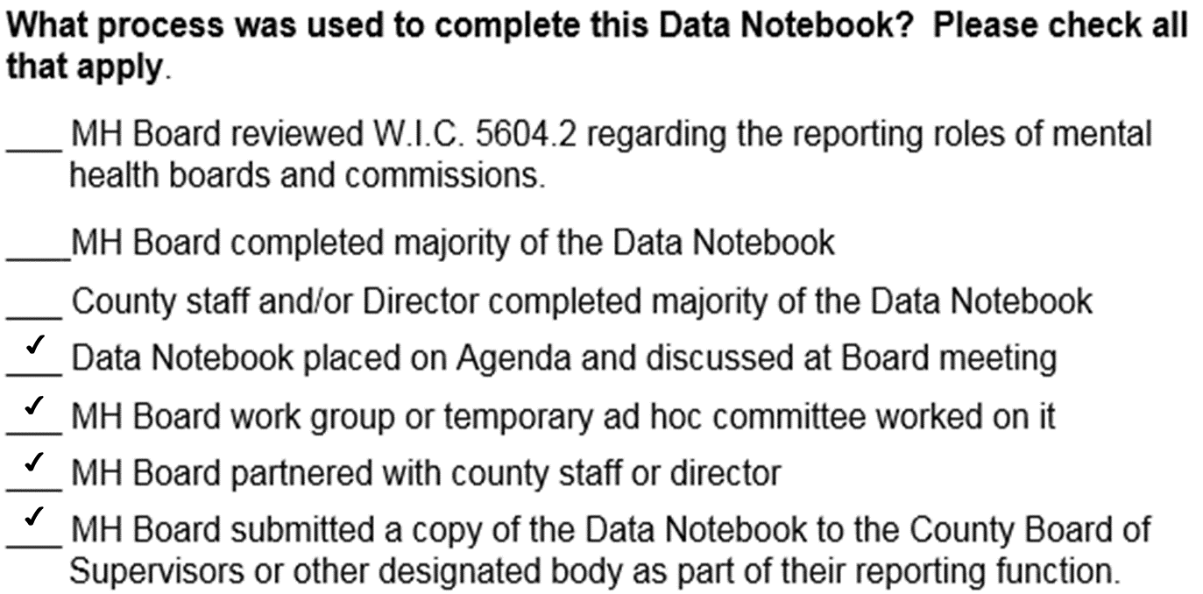

**B. Does your Board have designated staff to support your activities? If yes, please provide their job classification.**

Yes, there is a secretary who is assigned to support the Behavioral Health Board

**C. What is the best method for contacting this staff member or board liaison?**

By email at [jmcmanus@co.Humboldt.ca.us](mailto:jmcmanus@co.Humboldt.ca.us)

**D. What is the best way to contact your Board presiding officer?**

In conclusion, this data notebook is a great opportunity to learn about Humboldt’s Children’s Mental Health services, and the strengths and opportunities in the system and community.

We would like to move towards more community input based on the HCTAYC model.

It is important to realize that mental health services do not occur in a vacuum. It requires community collaboration – mental health providers, community leaders, clients, families, education, law enforcement, Tribes, preschools, medical providers, family resource centers, and HSU (training/education of providers). We all have the responsibility and opportunity to build relationships, trust, and knowledge of each other’s systems.

Once this information is gathered, it should be reviewed by the BHB and then emailed to [DataNotebook@CMHPC.CA.GOV](mailto:DataNotebook@CMHPC.CA.GOV) by May 25, 2017.