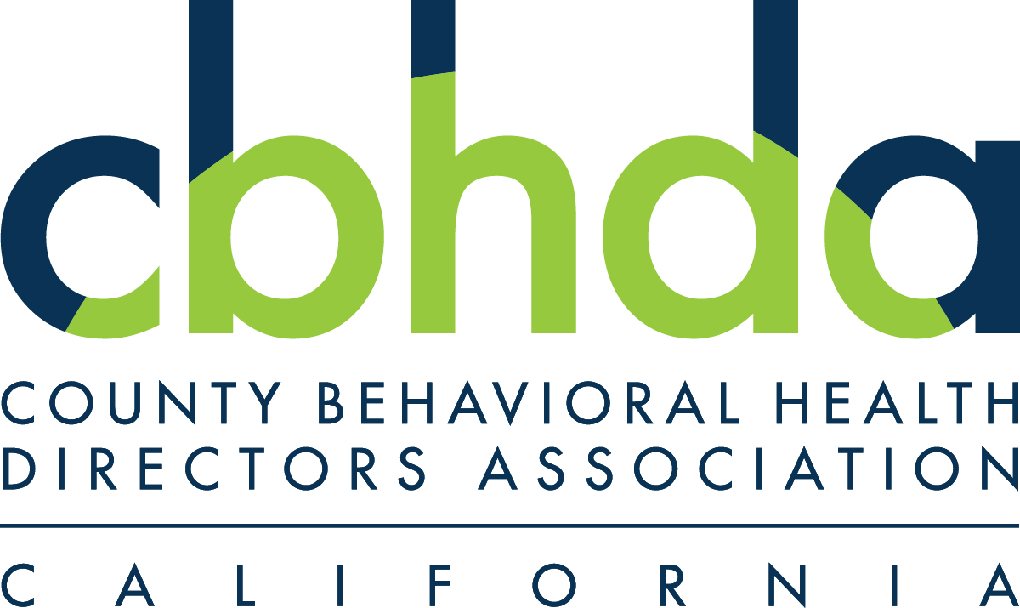

April 15, 2020

The Honorable Anthony Rendon
Speaker
California State Assembly
State Capitol, Room 219
Sacramento, CA 95814

The Honorable Phil Ting
Chair, Assembly Committee on Budget Committee
California State Assembly
State Capitol, Room 6026
Sacramento, CA 95814

The Honorable Toni Atkins
President pro Tempore
California State Senate
State Capitol, Room 205
Sacramento, CA 95814

The Honorable Holly Mitchell
Chair, Senate Budget and Fiscal Review
California State Senate
State Capitol, Room 5019
Sacramento, CA 95814

RE: COVID-19 Crisis: Vulnerable Populations in Board and Care Homes

Dear Speaker Rendon, pro Temp Atkins, Chair Ting and Chair Mitchell:

The undersigned behavioral health entities and organizations appreciate the efforts on the part of the California Legislature to strengthen California’s already commendable response to the COVID-19 public health crisis. However, there has been an overlooked need within the community, California’s fraying board and care infrastructure for low-income vulnerable residents. We want to make the Legislature is informed of the challenges that board and care facilities licensed by the California Department of Social Services (CDSS) – Community Care Licensing (CCL) are under today and the vital role that they play in the public behavioral health system serving vulnerable clients who would experience homelessness or be institutionalized without them. Board and cares that serve low-income vulnerable Californians with serious mental illness, older adults, and other disabilities were in a crisis of closures and poor conditions prior to the COVID-19 pandemic, and the pandemic has only exacerbated these challenges.

Additionally, in the wake of the pandemic, several state implemented policy changes have increased the demand for board and cares without new dedicated resources, including: Project Roomkey, the closure of the State Hospitals to new admissions for Incompetent to Stand Trial and Lanterman-Petris-Short Act clients, the release of 3,500 inmates from the California Department of Corrections and Rehabilitation (CDCR), and the Judicial Council’s recent $0 bail emergency Rule of Court. A substantial portion of these populations have a serious mental illness and are in immediate need of residential facilities that provide assistance with activities of daily living including medication, meals, and personal hygiene.

The Board of State and Community Corrections reports through their Jail Profile Survey in June 2019 that there were 22,412 open mental health cases and 5,223 individuals assigned to mental health beds in jails across the state. Approximately 30 percent of individuals in CDCR institutions are receiving treatment for a serious mental disorder in 2017, an increase of 150 percent since 2000 according to Stanford University. The three largest psychiatric facilities in the United States are jails: Rikers Island Jail in New York City, Twin Towers Correctional Facility in Los Angeles, and Cook County Jail in Chicago. A substantial number of individuals released by CDCR and local jails will need county behavioral health services and residential placements.

Local officials are looking towards fraying board and care infrastructure as placements for many of the populations described above exiting jail, prison, institutions, and homelessness and need a higher level of support than living with friends, family, or in a hotel/motel can provide. Counties alongside the CCL have been working closely providing technical assistance to board and care operators on how to institute infection control including physical distancing, preventive practices, and sanitation strategies in congregate settings.

The residents of board and cares are dependent adults and seniors with mental health and substance abuse histories in need of a structured supportive environment. By the time they are in for these board and cares homes, they are likely to have had multiple hospital admissions, experienced homelessness, incarceration, and or have suffered some other traumatic medical condition like a stroke, TBI, renal failure or diabetes. They are likely be a person of color, with language needs, and increasingly older population. These individuals require the types of assistance with their activities of daily living (ADLs) provided for in board and are facilities. For example, they are no longer able to manage their medications, provide for the basic needs like food and shelter, or manage their own monies. These residents are in the high-risk population for experiencing severe cases of COVID-19 due to underlying physical comorbidities, and potentially death as a result.

In addition to those new populations added to an already strained board and care safety net, in parts of the state experiencing higher numbers of COVID-19 cases, county behavioral health has been alerted of the need to create additional inpatient psychiatric capacity so that some hospitals can surge to meet the needs of COVID-19 patients. This has already started in Los Angeles County. As this pandemic evolves, county behavioral health is more reliant than ever on board and cares as the only viable alternative to inpatient facilities that are closed or seeking to shift acute psychiatric patients out of their general acute care facilities.

The County Behavioral Health Directors Association and the Steinberg Institute have requested that the Department of Heath Care Services urgently submit a COVID-19 Public Health Emergency Section 1115(a) Waiver proposal to the federal Centers for Medicare and Medicaid Services (CMS) for approval to allow for Medicaid funding for board and cares . The proposed waiver would add, an additional $1597 per month per Medi-Cal beneficiary in a board and care facility to pay for increased staffing and cleaning costs at these facilities, and for those facilities serving individuals with serious mental illness, effectively bring these facilities up to the Level Two payment tier ($2,666) for a Regional Center client. In other words, for the duration of the COVID-19 emergency response, this waiver would lift those facilities currently receiving only $35/ day to provide all the care and supervision required by their license to $87.50/day reimbursement. We respectfully urge the Legislature’s support in requesting DHCS submit this waiver proposal to CMS to draw down additional federal dollars for a crucial piece of California’s safety net for our most vulnerable Medi-Cal beneficiaries.

In addition to preserving existing infrastructure, this proposal would provide needed incentives for private pay facilities to expand the number of beds available to Medi-Cal beneficiaries.

Under the proposed 1115(a) waiver, board and care facilities would be eligible for a rate increase to cover COVID-19 response associated costs such as: 1) increased wages and hazard pay to staff to ensure appropriate levels of staffing for resident safety; 2) purchase of critical Personal Protective Equipment (PPE), and sanitizing and cleaning supplies mandated by the state licensing entity; 3) food for residents who normally receive meals at offsite day programs but now are receiving all meals within their facilities; 4) creating and maintaining isolation and quarantine zones within facilities; 5) increased supervision of residents to encourage compliance with hygiene and social distancing mandates; 6) increased staff education on proper use of PPE, conservation of PPE, isolation and quarantine strategies, and how to encourage residents to comply with “stay at home” orders. This proposal is consistent with Governor Newsom's April 10th announcement regarding the need to protect residents and employees at nursing home and residential care facilities.

Without additional investment, these care facilities will quickly be overwhelmed, unable to prevent and address COVID-19 outbreaks, and may close, leaving county and state agencies scrambling to secure appropriate placements for extremely fragile individuals in the midst of a crisis.

It is for these reasons that CBHDA and the Steinberg Institute’s request your consideration and support for submission of a Medicaid COVID-19 Public Health Emergency Section 1115(a) Waiver to ensure that board and care facilities serving vulnerable populations in California are adequately funded to meet the current moment and ensure the safety and wellbeing of individuals with serious mental illness and substance use disorders.

Sincerely,

Michelle Doty Cabrera Maggie Merritt
Executive Director Executive Director
CBHDA Steinberg Institute

cc: Members of the Assembly Budget Subcommittee #6 on Budget Process Oversight and Program Evaluation
Members of the Senate Special Budget and Fiscal Review Subcommittee on COVID-19 Response
Keely Martin Bosler, Finance Director, California Department of Finance
Dr. Mark Ghaly, Secretary, California Health and Human Services Agency
Dr. Bradley Gilbert, Director, California Department of Health Care Services
Dr. Kelly Pfeifer, Deputy Director, California Department of Health Care Services
Richard Figueroa Jr., Office of Governor Newsom
Tam Ma, Office of Governor Newsom
Marjorie Swartz, Principal Consultant, Office of Senate President pro Tem Atkins
Mareva Brown, Principal Consultant, Office of Senate President pro Tem Atkins
Scott Ogus, Consultant, Senate Budget and Fiscal Review Committee
Renita Polk, Consultant, Senate Budget and Fiscal Review Committee
Agnes Lee, Policy Consultant, Speaker’s Office of Policy
Gail Gronert, Special Assistant, Speaker’s Office of Policy
Andrea Margolis, Consultant, Assembly Committee on Budget
Nicole Vazquez, Consultant, Assembly Committee on Budget

See Board of State and Community Corrections Jail Profile Survey. Data accessed: November 22nd, 2019.
See Stanford University, “The Prevalence and Severity of Mental Illness Among California Prisoners On The Rise” (Apr. 2017)

