AMADOR COUNTY: DATA NOTEBOOK 2014
FOR CALIFORNIA
MENTAL HEALTH BOARDS AND COMMISSIONS

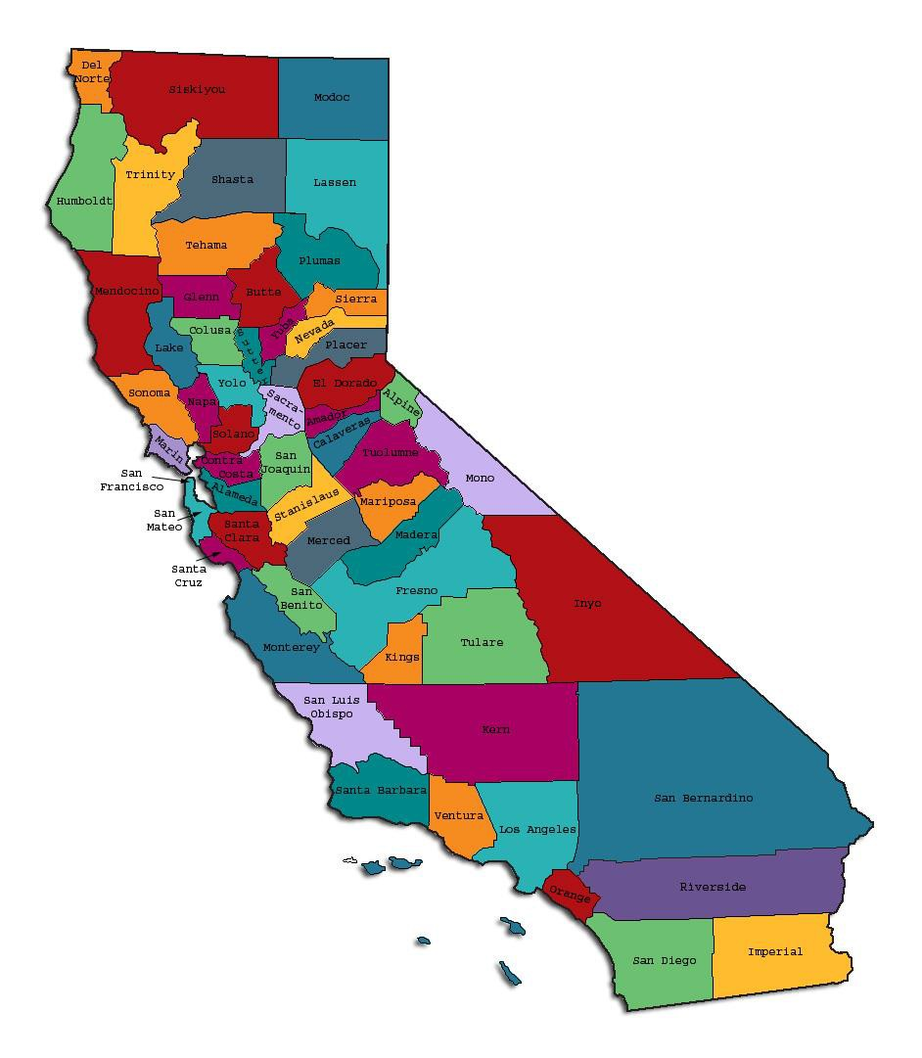

Prepared by California Mental Health Planning Council, in collaboration with: California Association of Mental Health Boards/Commissions, and APS Healthcare/EQRO

This Page Intentionally Left Blank.

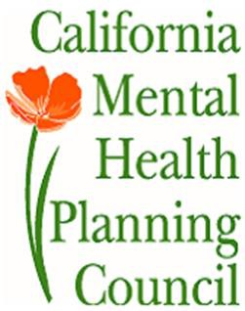Date: April 20, 2014

To: Chairpersons and/or Directors

Local Mental Health Boards and Commissions From: California Mental Health Planning Council Subject: Instructions for Data Notebook 2014

We ask that this report be prepared by the MH Board or Commission members. You are the most important resources for identifying program strengths and needs in your community.

On the first page, please fill in the requested information for your county websites:

- Department of Behavioral Health/ Mental Health
- Public reports about your county’s MH services.

Please send a copy of the filled-in first page to the Planning Council along with your final report which contains your answers to the questions in the Data Notebook. Please submit your report within 60 days by email to:

DataNotebook@cmhpc.ca.gov.

Or, you may mail a printed copy of your report to:

- Data Notebook Project
- California Mental Health Planning Council
- 1501 Capitol Avenue, MS 2706
• P.O. Box 997413 Sacramento, CA 95899-7413

Please examine the enclosed information, which will help you discuss the questions in the Data Notebook. We provide examples of recent mental health data for your county. In some figures, the term “MHP” is used to refer to your county’s Mental Health Plan.

Some data comes from APS Healthcare/EQRO, which gave permission to use their figures and tables, prepared for review of each county’s Medi-Cal Specialty Mental Health services. Data in this packet came from the following review cycle:

X Fiscal Year 2013 -- 2014: http://caeqro.com/webx/.ee85675/

Fiscal Year 2012 -- 2013: http://caeqro.com/webx/.ee851c3/

For some questions, you will need to consult your local county Quality Improvement Coordinator, and/or Mental Health Director. If you are not able to address all of the questions, just answer the ones you can. Thank you for your participation in the Data Notebook Project.

This Page Intentionally Left Blank

Amador County: Data Notebook 2014

FOR CALIFORNIA
MENTAL HEALTH BOARDS AND COMMISSIONS
County Name: Amador Population (2013): 36,204
Website for County Department of Mental Health (MH) or Behavioral Health:

http://www.amadorgov.org/services/behavioral-health/mental-health

http://amador.networkofcare.org/mh/

Website for Local County MH Data and Reports:

Website for local MH Board/Commission Meeting Announcements and Reports:

Specialty MH Data from review Year 2013-2014: http://caeqro.com/webx/.ee85675

Total number of persons receiving Medi-Cal in your county (2012): 6,327 Average number Medi-Cal eligible persons per month: 4,877 Percent of Medi-Cal eligible persons who were:
Children, ages 0-17: 40.7 %

Adults, ages 18-59: 45.3 % Adults, Ages 60 and Over: 14.0 %
Total persons with SMI1 or SED2 who received Specialty MH services (2012): 452
Percent of Specialty MH service recipients who were: Children 0-17: 23.9 %
Adults 18-59: 69.2 %

Adults 60 and Over: 6.9 %

1 Serious Mental Disorder, term used for adults 18 and older.
2 Severe Emotional Disorder, term used for children 17 and under.

This Page Intentionally Left Blank

INTRODUCTION: Purpose, Goals, and Data Resources
This Data Notebook has been developed for the use by the local mental health (MH) boards and commissions by a yearlong workgroup comprised of members from:
- California Mental Health Planning Council (CMHPC)
- California Association of Local Mental Health Boards and Commissions (CALMHB/C)
- APS Healthcare/ EQRO (External Quality Review Organization) Our plan is for the Data Notebook to meet these goals:
- Assist local boards to meet their mandates to review the local county mental health systems, identify unmet needs, and recommend improvements.
- Provide a professional format for submitting reports to their local Board of Supervisors, and/or their county Director of Mental Health Services.
- Function as an educational tool for local boards, whose members have varying levels of skills, frequent turnover, and need ‘refresher’ training about using data.
- Help the CMHPC fulfill its mandates to review and report on the public mental health system in California, which also helps provide evidence for advocacy.
Data reporting drives policy, and policy drives funding for programs. But the data must be both recent and available to the public, or else it is not useful. So, the CMHPC will provide examples of local data from current public reports. We focus on two broad areas: (1) evaluation of program performance, and (2) indicators of client outcomes.
We recognize that each county has a unique population, resources, strengths, and needs. Thus, there is no single perfect data source to answer all the important questions one might ask about mental health services. However, the following data resources will help board members answer questions in this Data Notebook:
- experience and opinions of the local mental health board members
- recent reports about county MH programs from APS Healthcare/EQRO
- data you request from your county QI Coordinator and/or Mental Health Director (because CMHPC does not have that data, and it’s not in other public reports)
- Client outcomes data provided by California Institute of Mental Health (CiMH) in their analysis of the most recent Consumer Perception Survey.
Some of our data comes from APS Healthcare/EQRO, which kindly gave permission to use their figures and tables, prepared for review of each county’s Medi-Cal Specialty Mental Health services. Those reviews are at: www.CAEQRO.com. You may find the full-length EQRO reports helpful because they summarize key programs and quality

improvement efforts for each county. They also describe strengths, opportunities for improvement, and changes in mental health programs since the last year.
Understanding changes in local programs can help consumers because of the massive re-organization of mental health services statewide. Some changes have been confusing to clients. The old state Department of Mental Health was eliminated in 2012 and many functions were moved to the Department of Health Care Services. Other changes due to federal health care reform and the Affordable Care Act affect how mental health services are provided, funded, and linked to primary health care or substance use treatment. Also, local counties have adjusted to major challenges.
Remember, this report is about your community, and what you and your stakeholders choose to discuss. Examining the data can indeed “Tell a Human Story.” But quantitative data (numbers) provides only part of the picture, for example:

- measures of whether the quality of program services improve over time
- whether more people from different groups are receiving services
- How many clients got physical healthcare or needed substance use treatment.

The other part of the story gives human context to the numbers. Such qualitative data (narrative, descriptions, or stories) tells more of the story, because we can:
- describe special programs targeted for outreach to specific groups
- examine how the programs are actually implementing their goals
- list concrete steps that are taken to improve services, and
- Tell what is being done to increase client engagement with continued treatment.

We hope this project contributes to ongoing quality improvement (QI) in mental health services. We seek constant improvement in our approach to quality because:
- needs change over time,
- all human endeavors are by nature imperfect,
- creativity gives rise to new ideas, and
- We can share examples of successful programs to help other communities.

One question is whether local boards are permitted to provide additional information, besides that requested in this Notebook. We always welcome supplemental reports about successful projects, or which the county administration uses to inform the public. Any additional reports may be attached in an “Appendix,” with the website address (if available). However, we emphasize such extra reports are not required.

Thank you for participating in this project. We hope this Data Notebook serves as a springboard for your discussion about all areas of the mental health system, not just those topics highlighted by our questions.

TREATING THE WHOLE PERSON:
Integrating Behavioral and Physical Health Care
Studies have shown that individuals with serious mental illness die, on average, 25 years earlier than the general population. This information makes improving the physical health of clients of great importance and should be a goal of county mental health departments along with providing effective and appropriate mental health services. Coordination of care for mental health, substance abuse and physical health is one way of accomplishing the goal.
The California Mental Health Planning Council does not have any data to provide to show how your county’s programs connect clients of mental health services with necessary physical health care. We ask that the local mental health board request information from your county mental health department for any data on numbers (or percent) of total mental health clients who are referred to, or connected with, physical health providers to assess, treat and monitor physical health issues.
If your county has data on numbers or percentages of clients who are also receiving physical health care, please include it in your Data Notebook you submit to the Council.

Check here if your county does not have such data or information.

Please describe any efforts in your county to improve the physical health of clients.
Amador County continues to work with community partners in initiating primary care physician consults. A referral procedure for primary care doctors has been established within Amador County Behavioral Health (ACBH), as well as communication methods to help coordinate care. The family/client advocate at ACBH inquires about primary care physicians during the client’s intake appointment, and can connect the client to appropriate resources if needed. Amador County has set a goal to have at least 75% of all clients to have a current release of information (ROI) with a primary care on file, and identified in the electronic health record.
Amador County has set a goal to work with the Amador County Public Health Department and community partners to advocate for smoking cessation/prevention, reduced substance abuse, healthy eating, exercise, and increased collaboration with primary care providers.

Amador County Behavioral Health also has a goal set within the Latino Engagement Performance Improvement Project (PIP) to partner with primary care physicians who work closely with the Hispanic and Latino communities to promote and coordinate with ACBH services.
The agency is in the early stages of these goals; however, a data tracking tool (via Survey Monkey) has been developed to collect and track this information, including a quarterly survey that is handed out to clients. This data will be available in upcoming meetings.

How does your county address wellness programs to engage and motivate clients to take charge of improving their physical health?
Amador County Behavioral Health contracts with community partners (i.e. Amador- Tuolumne Community Action Agency (ATCAA) and Sierra Wind Wellness Center) who supports, encourages, and engages clients in improving their physical health. This includes providing resources, referrals, and linkage to appropriate providers as needed. Sierra Wind Wellness Center offers groups focusing on physical health and wellness, including a walking and yoga class. The center also provides daily lunches as well as washers and dryers for client use.

Mental Health Service Act (MHSA) is finalizing a recurring Wellness Day in outlying areas to provide resources and support for the overall health of clients. These resources include benefit acquisitions, referrals to local agencies and organizations, nutritional information, along with mental health and stigma reduction information.
Community partner contractors will be asked to post their services and activities on the Network of Care website to provide information in a single location. In the future, this will be added to contracts with Amador County.

We will pursue senior representation (as a board member) on the BHAB and connection with the senior peer counseling program and the senior center.

NEW CLIENTS: One Measure of Access
One way to evaluate the quality of mental health services outreach is to measure how many clients receive services that have never been part of the service system before (“brand new” clients). Another measure is how many clients return for services after a period of time with no services (“new” clients).
The California Mental Health Planning Council is exploring how each county mental health department defines “new” clients, and how a client is labelled when they return for additional services. This information is important in determining whether your county has a “revolving door,” that is, clients who are in and out of mental health services repeatedly. This data is one indicator of the success of your county’s programs in closing cases appropriately and providing adequate discharge planning to clients.
This data is not currently reported by the counties to the state. The Council does not have data to provide to you. This information should be requested from your county mental health department.

Check here if your county does not have this information.

How does your county define 'new' client for those individuals who have previously received services, but who have not received services for a while? (e.g., 6 months, 12 months, 2 years?)
Data is not currently available, however, ACBH currently does not distinguish new from returning clients; however, the agency has started inputting in the electronic health record the reason for client discharge to track and determine why cases have closed.
From January 2014 to June 2014, a total of 449 services were closed within ACBH. (This does not mean that the client necessarily left all services). Please see the following table for Reason for Discharge from January 2014 to June 2014.

REASON FOR DISCHARGE | NUMBER OF CLIENTS
ADMINISTRATIVE | 275
CLIENT WITHDREW | 135
DECEASED | 3
ACHIEVED GOALS | 7
INCARCERATED | 3

MOVED | 15
NON-COMPLIANT WITH TREATMENT | 4
OTHER SERVICE SYSTEM | 1
PATENT GUARDIAN WITHDREW | 6

Please provide any data your county has on the number of 'new' clients last year. And if you have it, how many of those new clients were brand new clients? You may need to ask your county mental health department for this data.
ACBH is currently in the process of switching to an electronic health record where this data will be available for tracking in the upcoming year; however, there are no data for 2014.

Question not listed; skips to #6 in document from the State.

REDUCING RE-HOSPITALIZATION: Access to Follow-up Care
Sometimes, an individual experiences acute symptoms of mental illness or substance abuse which can result in a brief stay in an acute care hospital. Receiving follow-up services after discharge from a short-term (3-14 day) hospitalization can be critical to preventing a return to the hospital.
The chart below shows the percentage of people discharged in your county who received at least one service within 7 days of discharge. Also shown is the percentage of those same people who were readmitted to the hospital. The chart also shows the same information for receiving services and being readmitted to the hospital within 30 days. Red indicates the numbers for services or events within 30 days, and the blue indicates services or events within 7 days of patient discharge. (CY = Calendar Year, e.g., 2011 or 2012, as indicated below).

Amador County:

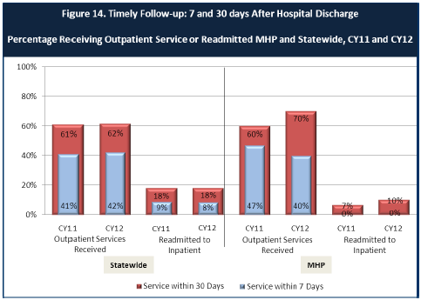

- Looking at the chart, is your county doing better or worse than the state? Discuss why (e.g., your county has programming available that specifically ensures a warm handoff for follow-up services).
In the Calendar Year 2011, the state had 41% of clients receiving outpatient services within 7 days after a hospital discharge and Amador County had 47%.
The data shows that for the calendar year of 2011, Amador County had slightly higher percentages of clients receiving outpatient services within 30 and 7 day after a hospitalization.
In the Calendar Year 2012, the state had 62% of clients receiving outpatient services within 30 days after a hospital discharge and Amador County had 70%.
In the Calendar Year 2012, the state had 42% of clients receiving outpatient services within 7 days after a hospital discharge and Amador County had 40%.
The data shows that for the calendar year of 2012, Amador County had an 8% increase in seeing clients 30 days following a hospital discharge compared to the state. However, Amador County had a 2% decrease compared to the state in seeing clients within 7 days of a hospital discharge.
Amador County increased the percentage of clients who received outpatient services within 30 days after a hospital discharge by 10% from 2011 to 2012. However, the percentage of clients who received outpatient services within 7 days after a hospital discharge decreased 7% from 2011 to 2012.
In the Calendar Year 2011, the state had 18% of clients readmitted to an inpatient setting within 30 days after a hospitalization, and Amador County had 7%.
In the Calendar Year 2011, the state had 9% of clients readmitted to an inpatient setting within 7 days after a hospitalization, and Amador County had 0%.
In the Calendar Year 2012, the state had 18% of clients readmitted to an inpatient setting within 30 days after a hospitalization, and Amador County had 10%.
In the Calendar Year 2012, the state had 8% of clients readmitted to an inpatient setting within 7 days after a hospitalization, and Amador County had 0%.
The data shows that in both calendar years (2011, 2012) Amador County had lower client readmissions to inpatient programs after both 30 and 7 days after a hospital discharge compared to the statewide average. However, based on the limited information presented, it is not substantial enough to draw precise correlations or conclusions.

Do you have any suggestions on how your county can improve follow-up and reduce re-hospitalizations?
In 2013, ACBH hired a full time crisis worker dedicated to crisis work and to improve on follow-ups after a crisis. In an attempt to reduce re-hospitalizations, the crisis worker also coordinates discharge planning for clients on an inpatient hospitalization, prior to the day of discharge.
Amador County will work to more effectively integrate drug and alcohol issues into the focus of the BHAB which is now called the BHAB.

What are the three most significant barriers to service access? Examples:
The Prevention and Early Intervention (PEI) Plan included community members, interviews, and focus groups that identified priority populations for Amador County. The PEI participants noted the lack of affordable child care and the unreliable transportation in Amador County appears to result in many children being left alone without adult supervision. Isolation, due to the rural communities, has proven to negatively affect the cognitive and emotional development of individuals, leaving them at risk to substance abuse, mental, emotional, and behavioral issues. Due to the reports from the PEI plan, three possible significant barriers to service could include: Rural Isolation, Transportation, and Child Care. Another barrier for ACBH clients is the delay time for psychiatric services. With limited psychiatric resources in Amador County, the wait time for a psychiatric appointment often takes longer than desired.

Navigating the complexity of the system is one of the obstacles. Our new client advocate is focused on helping clients deal with the complexity of paperwork, scheduling and follow-up. She has condensed forms to reduce the paperwork complexity.

Child care is another obstacle as some clients need to attend an appointment but are unable to obtain child care on short notice.

Too few adult/child providers (therapists) at ACBH.

ACCESS BY UNSERVED AND UNDER-SERVED COMMUNITIES

One goal of the Mental Health Services Act (MHSA) is to reach unserved and underserved communities, especially communities of color. The MHSA promotes outreach into these communities to engage these communities in services. If individuals and families in these communities are not accessing services, then we may need to explore new ways of reaching them. Or, we may need to change our programs to meet their mental health needs in ways that better complement their culture.
From data the counties report to the state, we can see how many individuals living in your county are eligible for Medi-Cal, and of those individuals, how many received mental health services. Are you serving the Medi-Cal clients who need your services?

Amador County:

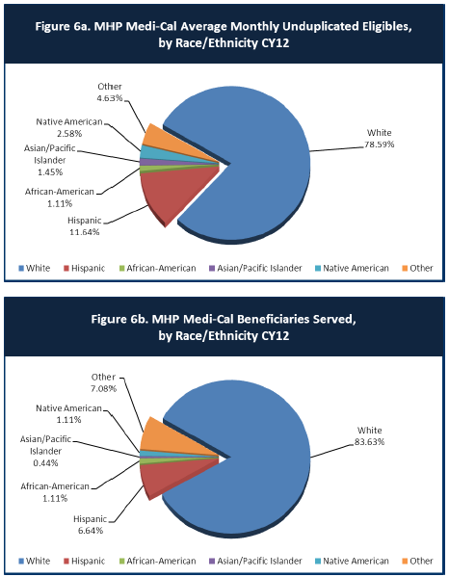

- Is there a big difference between the race/ethnicity breakdowns on the two charts? Do you feel that the group(s) that need services in your county are receiving services?

 | Individuals living in Amador County who are eligible for Medi-Cal (in %) | Medi-Cal beneficiaries served in Amador County for mental health services (in %)
White | 78.59 | 83.63
Hispanic | 11.64 | 6.64
African-American | 1.11 | 1.11
Asian/Pacific Islander | 1.45 | 0.44
Native American | 2.58 | 1.11
Other | 4.63 | 7.08

Discussed that undocumented persons, often Spanish speaking, may not be receiving services due to fear of seeking services. There is not a big enough difference between the information presented. However, there are likely still access and stigma issues that would impact groups receiving services, particularly for minority ethnic populations.

What outreach efforts are being made to reach minority groups in your community?
Amador County’s MHSA Steering Committee also serves as a Cultural Competency Committee, and is representative of the community. Currently the Steering Committee consists of approximately 10% Latino members, with others representing Native American, Cambodian, Older Adult and isolated rural communities. The board meets bi- monthly, and in the 2013-2014 fiscal year, the focus has been on increasing access and engagement for the Spanish- speaking Medi-Cal population.

The Latino Engagement Committee was also formed to help better serve the Spanish- speaking population. The team, which includes a representative of the Latino population and a client/family advocate among others, meets monthly to increase the outreach and engagement of the Latino population.

The staff, contractors, and community partners connected to ACBH, are provided online and in- person cultural competency trainings. Examples include community training such as Voices: Cultural perspective on Mental Health Video Series, NAMI’s In Our Own Voice, Bridges out of Poverty, and other guest speakers. Trainings that are provided include Interpreter Services Training: Training for Mental Health Clinicians Building Bridges for Better Communication, Mental Health First Aid, and the Relias online learning management, which offers over 400 courses to staff and contractors.

ACBH has a designated Cultural Competence/Ethnic Services Manager (CC/ESM) who promotes the development of appropriate mental health services that will meet the diverse needs of the county’s population. At this time the CC/ESM is Christa Thompson, MSW.

ACBH has contracted with the following to help ensure culturally competent activities:
  - The Language Line for phone interpretation
  - Translation of written material into Spanish

Amador-Tuolumne Community Action Agency (ATCAA) provides culturally competent outreach, support, and linkage to the Spanish speaking and isolated rural areas of Amador County
Promotores de Salud provides outreach, engagement, transportation, and translation services to the Latino population
Sierra Wind Wellness Center offers a weekly White Bison group for Native Americans, LGBTQ groups, and bilingual peer support for Spanish speaking clients.

Do you have suggestions for improving outreach to and/or programs for underserved groups?
Recommended that we add outreach to churches and faith based organizations.

Sierra Wind (community partner) is reaching out to outlying areas. “Wellness Day” is another means to reach out to various groups such as Spanish speaking and the seniors.

CLIENT ENGAGEMENT IN SERVICES

One MHSA goal is to connect individuals to services they need to be successful. Clients who stop services too soon may not achieve much improvement, nor is it likely to last. So it is important to measure not only who comes in for treatment, but also how long they stay in services. Here we are considering individuals with high service needs, not someone who just needs a ‘tune-up.’ Although not every individual needs the same amount of services, research shows that when someone with severe mental illness continues to receive services over time, their chances of recovery increase.
Engagement in services, also called ‘retention rate’, is important to review. If individuals come in, receive only one or two services and never come back, it may mean the services were not appropriate, or that the individual did not feel welcome, or some other reason that should be explored. Again, we recognize that some individuals only need minimal services, but here we are looking at those with severe mental illness. Ultimately, the goal is to ensure they are getting needed services and are on the road to recovery. But we would not know that unless we look at how many services individuals received over time.
The chart below shows the number of Medi-Cal beneficiaries in your county who received 1, or 2, or 3, or 4, or 5, or more than15 mental health services during the year. For individuals experiencing severe mental illness, the more engaged they are in services, the greater the chance for lasting improvements in mental health.

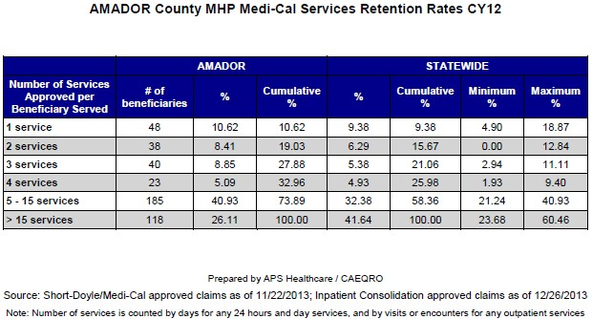

Do you think your county is doing a good job at keeping clients engaged in services? If yes, how? If not, why?
According to Medi-Cal billings reported to the Department of Health Care Services and reflected in ACBH’s CAEQRO Report, in 2012, Behavioral Health served a total of 452 individuals out of a total of 4,877 eligible individuals. This is a penetration rate of 9.27%. 32.97% of Amador Medi-Cal clients in 2012 came in for 4 or less services, compared to 25.89% for the statewide services.

It is also important to note that in the Youth and Family Consumer Perception Surveys, 100% of respondents agreed or strongly agreed that “services were available at times that were convenient for us.” This could reflect that due to the extra hour of productivity a day in ACBH allows for more availability for school aged children to be seen.

ACBH has also brought on a peer and family advocate who has recently started meeting with new clients before their assessment/intake appointment. The advocate meets with the client to provide her story of recovery, answer any needed questions, and ensures the client that they have an advocate whom they can turn to for support or needed resources.
Phone screening for intakes might help with engagement, helping the person to feel connected sooner, especially if the appointments are taking longer than two weeks for a new intake.

For those clients receiving less than 5 services, what is your county doing to follow-up and re-engage those individuals for further mental health services?
The new Client/Family Advocate has begun following up with clients who are scheduling intake appointments and not showing up, and with clients who have completed the assessment yet have not returned to complete a treatment plan. The front desk also assists with follow up.

Looking at the previous chart of who is being served by race/ethnicity in your county, do you have any thoughts or ideas to share regarding your county’s engagement of underserved communities? Answered in #10.

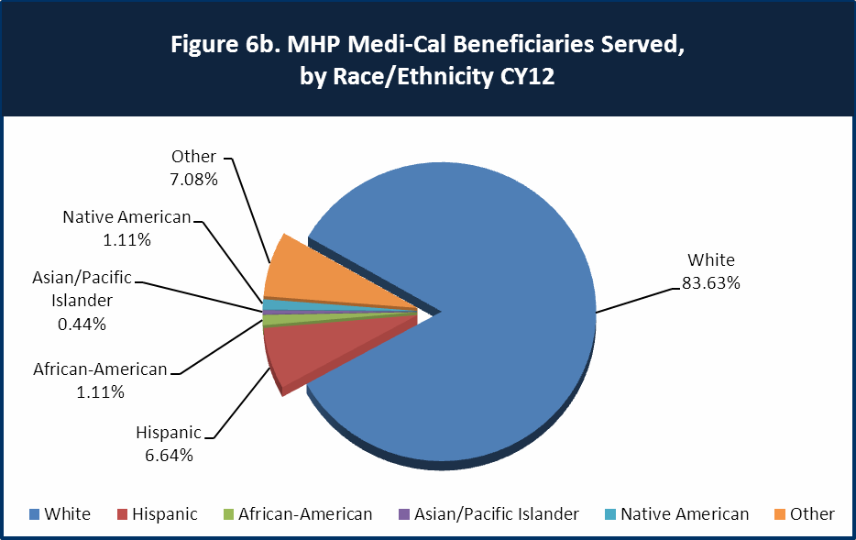

CLIENT OUTCOMES: Consumer Perception Survey (August 2013)

Ultimately, the reason we provide mental health services is to help individuals manage their mental illness and to lead productive lives. We have selected two questions from the Consumer Perception Survey which capture this intention. One question is geared toward adults of any age, and the other is for children and youth under 18.
Below are the data for responses by clients in your county to these two questions.

For general comparison, statewide reference data for various sized counties are shown in the tables on page 19.
The total numbers of surveys completed for Adults or Children/Youth in your county are shown separately in the tables below, under the heading “Total.”

Q1. Adults. As a direct result of the services I received, I deal more effectively with daily problems.

 | Strongly Disagree | Disagree | Neutral | Agree | Strongly Agree | Total
Number of Responses | 0 | 1 | 7 | 13 | 12 | 33
Percent of Responses | 0 % | 3.0 % | 21.2 % | 39.4 % | 36.4 % | 100.0 %

Q2. Children/Youth. As a result of services my child and/or family received, my child is better at handling daily life.

 | Strongly Disagree | Disagree | Neutral | Agree | Strongly Agree | Total
Number of Responses | 0 | 4 | 3 | 0 | 1 | 8
Percent of Responses | 0.0 % | 50.0 % | 37.5 % | 0 % | 12.5 % | 100.0 %

Are the data consistent with your perception of the effectiveness of mental health services in your county?
Data from the 2013 Consumer Perception Surveys, states that 75.8% of adult clients surveyed agreed or strongly agreed that as a direct result of the services they received, they are able to deal more effectively with daily problems.

The data also indicates that only 12.5% of guardians of youth/children believe that as a direct result of the services they received, their children are better at handling daily life. 50% disagreed with this statement. According to ACBH’s PEI Plan, children and youth in stressed families, children and youth at risk of school failure, and children and youth at risk of or experiencing juvenile justice involvement were 3 of the 6 priority populations identified, making the data consistent with the perception of effectiveness.
SUGGESTED TO ADD A QUESTION TO THE SURVEYS TO DETERMINE WHICH GUARDIANS ARE GRANDPARENTS RAISING GRANDCHILDREN.

Do you have any recommendations for improving effectiveness of services?
ACBH is participating in the California Institute for Behavioral Health Solutions (CiBH) Learning Collaborative, which bring together multiple counties and CiBH faculty to help implement best practices for an identified topic, such as advancing recovery. In the Learning Collaborative, ACBH has been shown data for the overall success of running a strengths-based program (i.e. working with a client’s strengths rather than focusing on their symptoms). These approaches integrate the importance of cultural competency as well. In taking this approach, other counties have seen less no-show appointments from clients, as well as an increase in client participation and success. Incorporating

recovery-based tools such as the Strength-Based Assessment and Milestones of Recovery Scale (MORS) into the services provided at ACBH could improve the effectiveness of services.

Online training has been put into place in the last 18 months and this allows staff to receive more training and to track it more effectively.

Many counties experience very low numbers of surveys completed. Do you have suggestions to increase the response rate?
The more available the survey is, the more likely the response rate will increase. For example, making the survey available online through Survey Monkey could increase the responses. ACBH had a total of 45 surveys completed in 2013, with an increase of 54 completed surveys in 2014.

Community providers / contractors can support clients completing surveys on line. This will be added into contracts to increase completion rate.

Lastly, but perhaps most important overall, with respect to delivery of services, do you have suggestions regarding any of the following:

- Specific unmet needs or gaps in services:
One gap and stated concern is the wait time for a psychiatric evaluation or medication management. At a CiBH Learning Collaborative, one county suggested having clients attend a medication orientation led by either the nurse or doctor. This was suggested as a one-time group for clients requesting psychiatric services. It was reported that clients are seen much quicker for the first appointment, the nurse could potentially complete medication treatment plans (reducing the work load on clinicians), as well schedule the next appointment with clients based on their needs.

Improvements to, or better coordination of, existing services
Having seniors bring in their medications to a Wellness day and have them evaluated by a pharmacist for recommendations regarding when, how to take them and to look for possible negative interactions.

Stigma reduction such as “Every Mind Matters” which is being supported at the local county fair at a booth put on by First 5.

Programs could be improved if they were sensitive to the needs, such as gender sensitive, child care considerations or improvements in areas not currently addressed in the current system of care.

New programs that need to be implemented to serve individuals in your county
Increase drug and alcohol resources, including for those who are adolescents and young adults. Additional Board members suggestions were various resources such as methadone, suboxone and needle exchanges.

References

Amador County Behavioral Health. (2014). Cultural competence plan. Amador County Behavioral Health. (2014). External quality review.

<END>

REFERENCE DATA: for general comparison with your county results

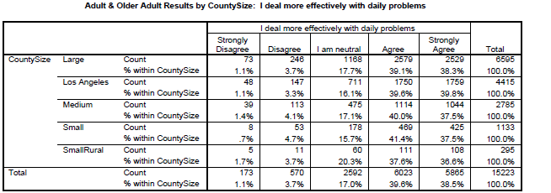

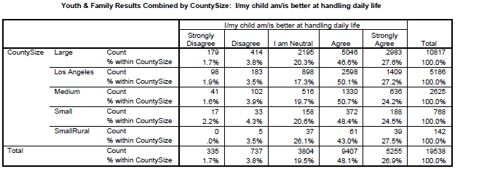
County Mental Health Plan Size: Categories are based upon DHCS definitions by county population.
- Small‐Rural MHPs = Alpine, Amador, Calaveras, Colusa, Del Norte, Glenn, Inyo, Lassen, Mariposa,
Modoc, Mono, Plumas, Siskiyou, Trinity

- Small MHPs = El Dorado, Humboldt, Imperial, Kings, Lake, Madera, Mendocino, Napa, Nevada, San Benito, Shasta, Sutter/Yuba, Tehama, Tuolumne

- Medium MHPs = Butte, Marin, Merced, Monterey, Placer/Sierra, San Joaquin, San Luis Obispo, San Mateo, Santa Barbara, Santa Cruz, Solano, Sonoma, Stanislaus, Tulare, Yolo

- Large MHPs = Alameda, Contra Costa, Fresno, Kern, Orange, Riverside, Sacramento, San Bernardino,
San Diego, San Francisco, Santa Clara, Ventura

- Los Angeles’ statistics are excluded from size comparisons, but are included in statewide data. Total Values (in Tables above) = include all statewide data received by CiMH for these survey items.

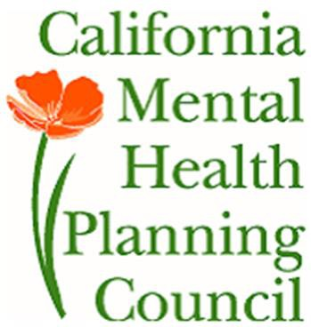

REMINDER:

Thank you for your participation in completing your Data Notebook report.

Please feel free to provide feedback or recommendations you may have to improve this project for the following year. We welcome your input.

Please submit your Data Notebook report by email to: DataNotebook@CMHPC.CA.GOV

Or, you may submit a printed copy by postal mail to:

  - Data Notebook Project
  - California Mental Health Planning Council
  - 1501 Capitol Avenue, MS 2706
• P.O. Box 997413
  - Sacramento, CA 95899-7413

For information, you may contact either email address above, or telephone: (916) 449-5249, or
(916) 323-4501

